


MASTER THESIS
Statistical Methods to Detect Direct and Palindromic Patterns in Bacterial Transcription Factor Motifs

Enoch Shin

MSc in Research and Innovation for Computer-based Science and Engineering
Supervisor: Dr. Ivan Erill Sagales
Department of Information and Communications Engineering

Cerdanyola del Vallès, 03 July 2026
Acknowledgements

I would first like to thank my advisor Dr. Ivan Erill Sagales, who provided me with the guidance and tutelage over the past several months to get up to speed in the essential biology and computing domain knowledge to execute this thesis. As I have a history and statistics background, Dr. Erill tailored the project to my skill set and to align with my intention behind participating in this master’s degree, which was to increase my skills and capabilities. Moreover, Dr. Erill helped me secure scholarship funding for my studies here at the Universitat Autònoma de Barcelona, and I am grateful to have had the opportunity to work with him.
I also wish to thank all the professors and academic administrators of the UAB’s Research and Innovation in Computer based Science and Engineering degree for their pedagogy and support in ensuring that I could successfully complete this course.
Spending these past nine months in Barcelona, meeting people from all over the world, and getting more immersed in Spanish and Catalonian culture has shown me that other ways of life are possible, though some problems are simply universal and inherent to the human experience in the 21st century. I want to acknowledge my newfound Catalan friend David for helping me experience a rich local perspective, as well as my classmates for their friendship and support.

AI Usage Declaration

Anthropic’s Claude and Google Gemini were utilized in the course of this research project as supporting tools. They were used for exploratory literature review, proofreading in writing, high-level understanding of concepts, and for boilerplate Python code syntax (e.g., generating ROC curves, subsetting a matrix). Gemini was also used to generate HTML code to collate the results into an easily readable format to review and compare results, but it did not govern experimental processes or the results themselves.

The full codebase was reviewed by Claude for sanity checking solely to verify any serious data leakage or systemic logic issues. Beyond this, the core logic of the analysis was designed and written independently, and the discussion comprising this report was written manually.

In sum, large language models were used solely as assistive tools and did not replace original scientific analysis, implementation design, or experimental evaluation.

Table of Contents
List of figures and tables 5
Abstract 6
Introduction and State of the Art 7
Experimental Techniques in Motif Discovery 8
Comparative Genomics and Information Theory in Motif Discovery 8
Motif Discovery Algorithms 9
Applying Comparative Genomics to Motif Discovery in Bacteria 10
Objectives 11
Methodology and Development 12
Overview of the Pipeline 13
Data Structure 13
Selection of Similarity Metrics 14
Detecting and Scoring Candidates in Diagonal Form 17
Significance Testing with Bootstrap Distributions 19
Methods of Evaluating Results 20
Thresholding Parameter Tuning and Result Concordance 21
Classification Evaluation 21
Results and Discussion 22
Tuning Threshold Percentage to Optimize Performance 23
Performance Evaluation 25
ROC and PR Discussion for CollecTF Data 25
ROC and PR Discussion for MEME Data 26
Confusion Matrices and Edge Cases 28
Inspecting the CollecTF Confusion Matrices 28
Inspecting the MEME Confusion Matrices 30
Conclusions 32
Bibliography 33

List of figures and tables

Figure 1. A simplified diagram of the Central Dogma of molecular biology. The promoter region, upstream of the gene, signals transcription initiation. The promoter region typically contains multiple motifs that are specific to a several regulatory proteins [3], [4], [5]. 7
Figure 3. Examples of bacterial TF actions. Part b) shows an example of TF homodimerization, where two identical TFs are paired together head-to-head [38]. 11
Figure 4. An example of a sequence logo from a contrived simple data set. Here, we see an example of a direct repeat pattern with GTCA-GTCA. 12
Figure 5. A comparison of the matrix of PIC metric vs that of the PIC – JSD. 16
Figure 6. A sequence logo visualization of the direct repeat pattern suggested by our plotted IC – JSD metric. 17
Figure 7. Histogram distribution of the PIC-JSD metrics (lower left triangle of the matrix only, as it is mirrored across the main axis). 18
Figure 8. The PIC-JSD matrix with arrows denoting the direction of traversal in the search. 19
Figure 9. Bootstrap distribution of the PIC-JSD shuffled space. 20
Figure 10. An inverse or palindromic search executed on the same simple example. 20
Figure 11. Concordance over thresholds and execution time by threshold for CollecTF data. Results are similar for MEME data. 23
Figure 12. Youden’s J and F1-score across 0-90% thresholds for winner-takes-all results. 24
Figure 13. Component and system (winner-takes-all) ROC and PR curves for the DRIPPY classification of the CollecTF data set. 25
Figure 14. Component and system (winner-takes-all) ROC and PR curves for the DRIPPY classification of the MEME data set. 27
Figure 15. Confusion matrices for CollecTF data on DR and IR detection. 28
Figure 16. Sequence logo for false negative DR observation Yersinia pestis biovar Microtus str. 91001 with the TF Q7CFX0. 29
Figure 17. DRIPPY output for both the DR and IR search results of Nostoc sp. PCC 7120’s transcription factor Q8YMM5. 29
Figure 18. Sequence logo for Vibrio vulnificus MO6-24/O with the TF Q7M7I9, demonstrating a single-sequence PWM offers uniform signal and thus no information to ascertain a pattern. 30
Figure 19. Confusion matrices for DR and IR detection for MEME data. 30
Figure 20. Sequence logo for MEME output 1, motif 5, with many poly-N patterns. 31
Figure 21. In order of appearance: MEME 3 Candidate 10, MEME 4 Candidate 3, and MEME 4 Candidate 4. 31

Table 1. Position probability matrix of a contrived example. 13
Table 2. Concatenated PPM of the simple example, where only indices 3 and 9 are shown for illustrative purposes. The full PPM would be 12 columns long, matching the sequence logo’s length of 12 base pairs. 15
Table 3. Scenario modeling the pitfalls of various concordance metrics using the simple example. We see the effect of applying the JSD as a penalty, and the downsides of using the Pearson and JSD alone in uniform cases. 16

Abstract

Motif discovery is a well-examined bioinformatics task to uncover transcription factor binding sites within the genome. Though several word-based, combinatorial, and machine learning methods exist to perform motif discovery, few methods exist to statistically evaluate the discovered motif candidates. By applying comparative genomics in a bacterial context, we can build a pattern-based statistical framework to evaluate putative candidates.

Introduction and State of the Art

Gene transcription determines a significant portion of an organism’s attributes and functions by controlling gene expression. Specialized proteins called transcription factors (TFs) modulate the gene expression process by binding to regions upstream of the gene, activating or repressing transcription initiation and thereby modulating the expression of genes in the organism [1]. Transcriptional regulation operates under the Central Dogma of molecular biology, which defines the two-step unidirectional flow of information from genotype to phenotype. DNA is transcribed by TFs into messenger RNA, which in turn is translated into active proteins that carry out tasks and functions that execute the phenotypes encoded in the genes [2].

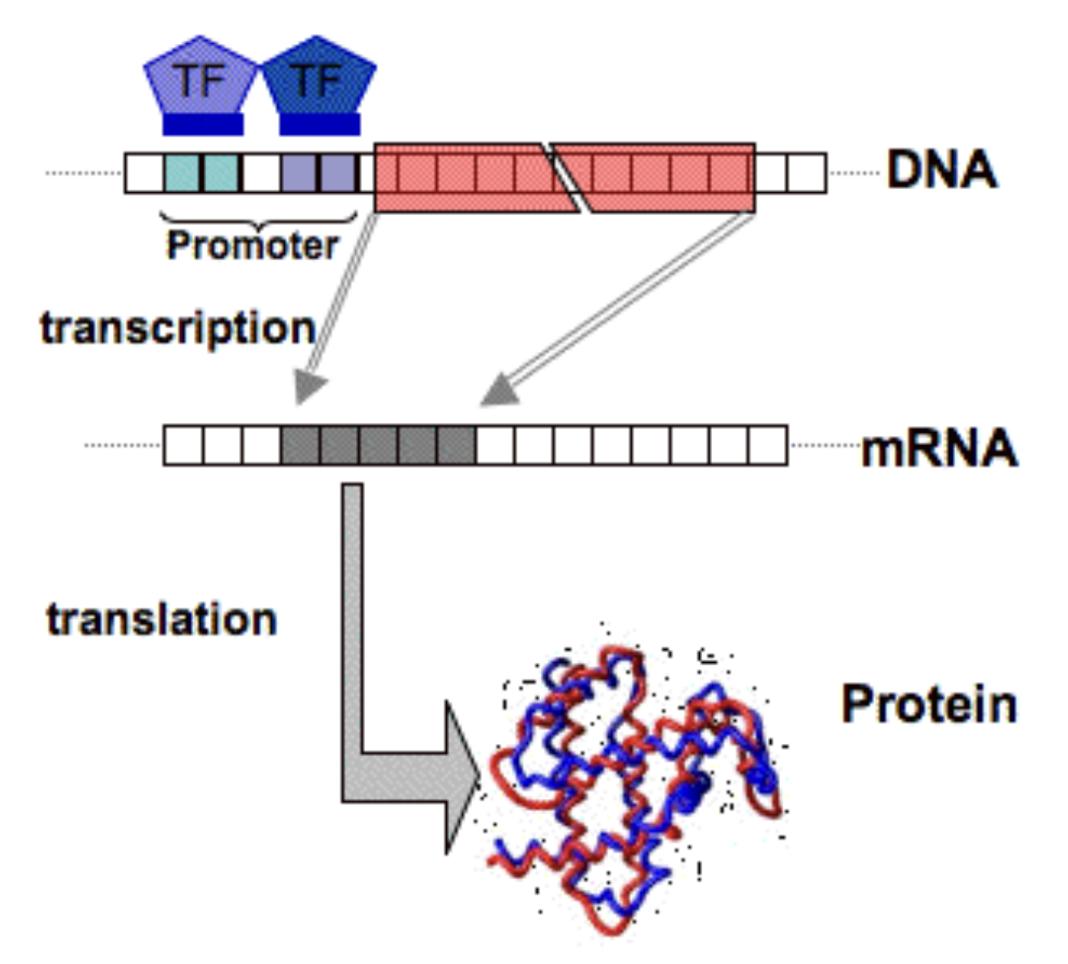
Figure 1. A simplified diagram of the Central Dogma of molecular biology. The promoter region, upstream of the gene, signals transcription initiation. The promoter region typically contains multiple motifs that are specific to a several regulatory proteins [3], [4], [5].

Understanding where TFs bind to the genome is a crucial component for understanding how gene expression is carried out in an organism. Transcription factor activity is triggered by short segments of DNA physically adjacent to the encoding gene known as binding sites, which lie within the area known as the promoter region. TFs bind specifically to their target sites by targeting sequence patterns known as motifs.

Discovering motifs is therefore a highly motivated task, as motifs act as signposts for TFs to activate or deactivate a gene. Finding TF binding sites within the genome is useful for practical applications such as diagnosing and treating chronic genetic diseases, targeted drug design, and toxicity prediction of peptides and proteins [6]. On a larger scale, identifying motifs is also a key component in computational modeling of transcriptional regulatory networks (TRNs), where multiple TFs and their target genes interact to modulate phenotypes and cell behaviors systematically within an organism. Bioinformatics aims to detect high-quality motifs to enable better understanding of how TFs interact across the genome and discover previously unknown targets, which in turn informs better models of cell states as a function of their genetic makeup [7], [8], [9].

While motif discovery is a highly motivated investigation in bioinformatics, doing so is challenging because motifs are inherently noisy; regulatory TFs tolerate variability within the sequences to which they bind [10]. All motifs are degenerate, where only a few nucleotides within the motif are relevant to its function [11]. This means TFs do not strictly discriminate for a specific, universally consistent and stable sequence of nucleotides: due to natural evolutionary mutations, TFs can still bind to sequences that look “close enough,” and this allowance for variation introduces inherent noise and uncertainty during the process of discovery. Moreover, de novo motif discovery – the process of finding motifs without prior sequence alignment – is further challenged by the fact that a motif’s location relative to its corresponding gene is unfixed. The motif can be either upstream or downstream of the gene, and the distance between the motif and the gene varies substantially [11]. Therefore, motif discovery can be considered a common approximate substring (CAS) problem, which is characterized as NP-hard [12].

Experimental Techniques in Motif Discovery

In the wet lab, experimental techniques such as ChIP-Seq (Chromatin Immunoprecipitation Sequencing) and RNA-Seq are used to assess TF activity and generate the data necessary for motif discovery [13]. In these techniques, biologists begin by growing an organism of interest in a petri dish. In ChIP-Seq, the transcription factor under investigation is bound to the DNA, after which the specific portions of DNA that attached to the TF are analyzed to report on which DNA patterns comprise the motif. On the other hand, RNA-Seq approaches the task by exploiting the transcription stage of the Central Dogma, comparing an experimental cell sample where the TF of interest has been deleted or overproduced [14]. Comparing the mRNA produced in the experimental sample to the control sample provides a snapshot of which genes were activated (or repressed) in response to the presence of the TF. In turn, the mRNA is sequenced and mapped back to the original genome, which elucidates the specific sequence of the genome that was transcribed by the TF. In other words, RNA-Seq offers a way to quantify the gene expression modulated by the TF.

These experimental techniques are low-throughput and costly. Crucially, they are limited as the results for each wet-lab experiment are specific to one genome only, meaning that the task of distinguishing true functional motifs from random variations due to background mutations is stymied by poor statistical power and high false positive rates [15], [16].

Comparative Genomics and Information Theory in Motif Discovery

In order to improve the motif discovery process, the data generated from experimental techniques can be analyzed using comparative genomics and phylogenetic footprinting, which is predicated on the concept that if a TF regulates a specific gene in one species, it likely regulates orthologs (equivalent genes) in related species [17]. In other words, if we assume a gene and the critical components of its motif sequence are conserved and thus largely similar across several evolutionarily related species, we can leverage the resulting larger sample size to detect true motifs across these species while filtering out noise from random natural variations and mutations. Zhang and Gerstein’s 2003 work “Of mice and men” explains that because regulatory elements like motifs are functionally important and are under evolutionary selection, they should have evolved much more slowly than other non-coding sequences, meaning they are more likely to be highly conserved over evolutionary timelines [17].

When performing motif discovery using with experimentally gathered data, DNA sequence segments are typically modeled as matrix representations, which can then be analyzed through the information theory framework. Information theory was conceptualized as early as 1948 with Claude Shannon’s watershed “A Mathematical Theory of Communication,” which was then applied in the biological context by Lila Gatlin’s “The Information Content of DNA” in 1966 [18], [19]. Thomas Schneider’s 1984 thesis formally applied information theory to TF binding sites, proposing that the information content inherent to binding sites is sufficient for such sites to be distinguished from the rest of the genome [20]. In essence, all of these works are founded on the notion that DNA is considered an information-bearing message, and by comparing multiple sequences known to be bound by a particular transcription factor, we can infer the likely morphology of its binding motif by applying statistical detection of overrepresented patterns across the sequences.

Motif Discovery Algorithms

Several algorithms have been developed to perform ab initio motif discovery (i.e., from scratch) by applying comparative genomics and information theory to existing sequence databases [21]. Motif discovery in silico allows for substantial reduction and refinement of the search space for more likely active binding site candidates, which in turn reduces the costs and cycle times of wet-lab testing to verify and understand their function [22].

Word-based combinatorial methods (also known as “enumerative”), as described in Pevzner and Sze’s “winnowing” algorithm, establish a dictionary of words comprised of all possible DNA sequence combinations of length l, with an assumed allowance of d mismatches within each word (e.g., ATGCGT and ATGCGA are the same "word" with a single-letter mismatch). This method employs graph theory to connect each word as nodes, with edges defined by similarity under variation d [23]. Words with more edges are likelier positive signals. While these word-based methods are exact in that they are guaranteed to find the globally optimum solution, their combinatorial nature makes them computationally expensive for longer motifs, as the quantity of all possible words in the dictionary scales exponentially with the search length [24].

Greedy algorithms seek to address the computation problem of combinatorial methods, as they are not guaranteed to find the global optimum, operating on iterative cycles that select locally optimum solutions at each step. These methods often use the position weight matrix (PWM), which describes the frequency of each of the four nucleotides at each index given a set of observed DNA sequences.

Hertz and Stormo’s 1999 CONSENSUS is an example of this class of greedy algorithm [25]. This algorithm iteratively performs increasingly larger group-wise matrix sequence comparisons, starting with a word of user-specified length n and a pairwise comparison that computes information content (IC) for sequences aligned to that length. Then, segments of the other observed sequences of length n are aligned with the first word, and the cycle continues, selecting for maximum IC. Unlike probabilistic algorithms, CONSENSUS is deterministic, in that its selection of best candidates does not rely on a stochastic process, being as it evaluates consistent paths that maximize IC.

Probabilistic algorithms are also greedy and address the combinatorial computation problem by leveraging stochastic behavior. Gibbs sampling and expectation maximization (EM) are key concepts employed by these algorithms. EM uses a semi-random candidate subsequence of length n and computes the probability that this subsequence was generated by the PWM, iteratively improving the seed to maximize the candidate’s conditional probability given the observed data [11], [26]. Gibbs sampling is conceptually similar, though it takes a stochastic approach. While EM operates on a weighted average across all subsequences, Gibbs sampling allows for weighted sampling where poor candidates can still be selected during the iterative process, thereby reducing the problem of getting stuck in a local optimum by introducing randomness [26].

MEME (Multiple EM for Motif Elicitation) is a popular implementation of an EM algorithm. It can locate short overrepresented sequence patterns in sets of sequences targeted by a transcription factor, but they generate multiple possible candidates with a variety of nucleotide sequence patterns and morphologies [27]. Based on an architecture proposed by T.L. Bailey and Elkan in 1994, MEME’s core mechanism uses the position weight matrix of nucleotide frequencies (Adenosine, Thymine, Cytosine, and Guanine) at each index position to fit a mixture model [28]. An iterative optimization process maximizes the model's likelihood to discover motif candidates of a user-specified length. Once a motif model converges, MEME evaluates its statistical significance by calculating an E-value, which represents the expected number of motifs with an equal or higher information content that one would find by pure chance in a random data set of the same size [28], [29].

Since the advent of MEME, several alternative toolkits such as HOMER (Hypergeometric Optimization of Motif EnRichment, 2010) or STREME (Simple, Thorough, Rapid, Enriched Motif Elicitation, 2021) pursue de novo motif discovery with different approaches, using tokenization and suffix trees to improve scaling ability, user friendliness, and accuracy [21], [30].

Other approaches are machine learning based [6], [31]. Genetic algorithms form the basis of methods like FMGA (Finding Motifs by Genetic Algorithm), which simulates a natural selection-like mechanism driven by a fitness function which scores and prunes randomly selected candidate motifs on similarity to the observed promoter sequences [32]. Other methods like KEGRU use recurrent neural networks to map the potential candidate sequence segments into vector representations [33]. Other machine learning algorithms use hierarchical LSTM (Long Short-Term Memory), time series, and deep learning [6]. A notable example of a deep-learning framework is DESSO, which integrates DNA shape feature detection to improve precision compared to five other methods, including deep learning-based and MEME-ChiP algorithms [34].

Applying Comparative Genomics to Motif Discovery in Bacteria

Across all these methods of in silico motif discovery, an algorithm output’s statistical significance (e.g. the E-values of found candidates) does not automatically equal biological significance. Seemingly compelling motif candidates can simply be reflections of background noise and chance repeats in the sequence. The problem is compounded in comparative genomics contexts, as orthologous sequences from closely related species have more commonalities beyond just the TF-binding motif.

Incorporating domain-specific knowledge heuristics related to TF structure can help refine outputs further. Many bacterial transcription factor proteins form dimers, more specifically through homodimerization, meaning two identical TF molecules form pairs that confer advantages such as increased specificity to targets [35]. Dimeric bacteria can be oriented in a manner that is head-to-head or head-to-tail, and this impacts the sequence morphology of the motifs they bind to [36]. Head-to-head TFs are oriented in a mirror fashion with 180-degree symmetry facing each other, meaning they can bind to palindromic motifs. This means that the motif forms a “reverse complement” pattern such as ATGC-GCAT. As DNA is double-stranded, the head-to-head orientation of the TF allows it to operate on both the top and bottom strand. On the other hand, head-to-tail homodimers, by nature of their orientation, tend to bind to symmetrical motifs as their singular orientation only allows them to transcribe unidirectionally on the same strand of DNA (such as GTTC-GTTC) [37].

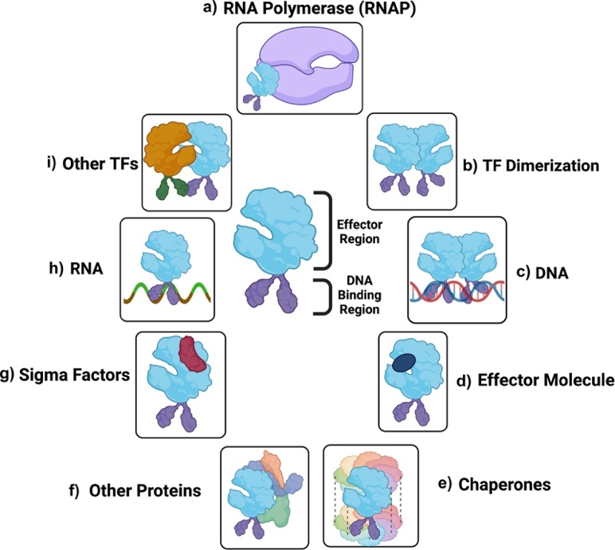
Figure 2. Examples of bacterial TF actions. Part b) shows an example of TF homodimerization, where two identical TFs are paired together head-to-head [38].

Therefore, the dimerization property of bacterial TFs can be applied to evaluate the plausibility and quality of the outputs of motif discovery algorithms. By focusing on the domain of well-studied bacterial TFs with known dimeric behaviors, we can evaluate the specific sequence morphology of potential motif candidates to create measures of quality – i.e., a measure of how “palindromic” a candidate motif is.

Objectives

The objective of this thesis is to create statistical frameworks that assess and justify which candidate motifs reported by discovery tools like MEME are more likely to be true TF-binding motifs.

Assessing the comparative quality of motif candidates is an iterative step serving as a noise filter that prioritizes candidates for further investigation [29]. Rather than introducing a new methodology for de novo discovery, of which there are many as discussed earlier, the goal is to design a data pipeline that refines and evaluates the discovered group of candidate motifs.

Given a set of binding site sequences across the FNR-CRP, LexA, and OmpR bacterial transcription factor families from CollecTF, we establish a data pipeline that outputs a statistical evaluation of the quality of the motif candidate, incorporating the direct repeat and palindromic properties of the bacterial domain as a guiding heuristic [39]. We will employ the matrix representations of the aligned sequences (the position weight matrix) to model their distributions and assess the bootstrap distribution plausibility of the discovered candidates.

Methodology and Development

This thesis uses two sources for data to create the DRIPPY (Direct Repeats and Inverted Patterns in PYthon) processing pipeline.

First, we use a collection of aligned sequences from the CollecTF database, which is a community-contributed database that documents experimentally validated TF binding sites in the Bacteria domain [39]. Our dataset from CollecTF consists of 52 unique transcription factors (identified by their UniProtID), across the families LexA, OmpR, FNR-CRP, which are TFs active across multiple species. The sample size is larger as some of the TFs are shared across multiple species (n = 68), though it is imbalanced, with 43 inverse repeat patterns and 25 direct repeats.

The justification for incorporating CollecTF data is to build the pipeline on known samples for which we have established ground truths on the motifs’ expected morphology. We expect that the discovered motifs should have sequence patterns that conform to palindromic or direct-repeat patterns as observed in existing literature. For example, the LexA TF is known to commonly have motifs of inverted repeat patterns [40]. This way, we can build the data pipeline on a known data set with confirmed ground truths.

The second data source is a collection of four MEME outputs, each of which contains 10 candidate motifs (n = 40). The data was first manually labeled by reviewing MEME’s sequence logo, a graphical display by Thomas Schneider which shows the consensus motif across the aligned sequences [41]. An example of a sequence logo is shown below.

The MEME sample is highly imbalanced, with 5 direct repeats, 11 inverse repeats, and 24 none-type labeled patterns.

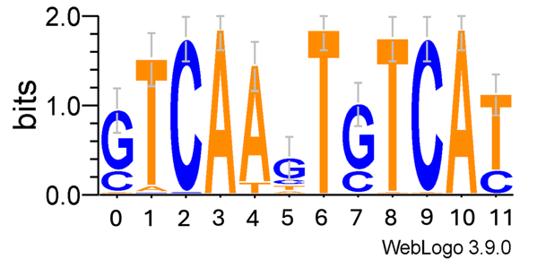
Figure 3. An example of a sequence logo from a contrived simple data set. Here, we see an example of a direct repeat pattern with GTCA-GTCA.

The MEME data is used as a validation set to test a real-life application of the proposed pipeline built in this thesis. The MEME set represents a collection of motif candidates that may have direct repeat, inverted repeat, or no patterns at all, and we have no prior domain knowledge based on which species or families they are associated with. This provides a realistic test workflow for motif candidate evaluation, where unlike the CollecTF set, we cannot apply known literature-backed heuristics to predict the likely outcome.

Overview of the Pipeline

To achieve our objective of detecting direct or inverse patterns in a set of sequences, we first define a metric appropriate for expressing similarity between pairs of indices within the data. Then, we determine a threshold for an acceptable cutoff point to discriminate between noise and a real pattern. We then return a list of candidates comprised of diagonal runs whose component cells all meet or exceed the threshold cutoff. The sum of the metric of those cells represents the score of the candidate. We then evaluate the candidate with bootstrapping, computing statistical significance of the scores compared to a randomized space.

Data Structure

At the start of the analysis, the principal data structure is the position probability matrix (PPM), which is constructed from sets of aligned sequences in FASTA or XML file formats. The PPM is a simple computation of the probabilities of each nucleotide across the aligned sequences. For example, if we have four sequences like so:
ACAGGT
ATAGGA
ACACCT
TTACCA

The resulting PPM would be computed as so for each position when the sequences are read left to right:

 | 1 | 2 | 3 | 4 | 5 | 6
A | 0.75 | 0 | 1 | 0 | 0 | 0.5
T | 0.25 | 0.5 | 0 | 0 | 0 | 0.5
C | 0 | 0.5 | 0 | 0.5 | 0.5 | 0
G | 0 | 0 | 0 | 0.5 | 0.5 | 0
Table 1. Position probability matrix of a contrived example.

The PWM is then derived using the probabilities like so:

$$W_{b, i}= log \frac{p(b, i)}{p(b)}$$

Where the weight W at base b, position i is defined as a logarithm of the observed probability divided by a prior background probability.

As discussed in the introduction, the PWM is frequently used in motif discovery to express the probability distribution of the nucleotides across the set of sequences under investigation. In our case, the goal is to detect similarity and concordance for each pair of indices in the aligned sequences to construct a self-comparison matrix that expresses pairwise internal relationships across all positions within the PWM. In this manner, we can visualize direct and inverted repeat patterns.

Selection of Similarity Metrics

The idea of our methodology is to analyze pairs of differing columns in to see if they form part of a repeat string. To do so, we can choose several metrics to detect highly similar pairwise positions. The information content (IC) is a key metric used throughout, defined with the Shannon entropy, H, as a measure of the weighted average information emitted by a source:

$$H = -\sum{p\left(x\right)log p\left(x\right)}$$

In this problem space, we assume a uniform prior, where each of the nucleotides A, T, C, and G are assumed to be equally likely (p = 0.25) under a null hypothesis where no information is conserved. In other words, the null hypothesis assumes that any given position within the motif is not inclined towards a specific nucleotide, as all four are equally likely.

We then compute a positional information content (PIC) using the average probability distribution of each pairwise combination of the observed probabilities in the indices across the matrix. The difference between the null uniform prior IC and the observed positional IC is the measure of conserved information found at an index: in other words, we can compute the amount of information gained compared to the null no-information state.

Other metrics can be employed to measure similarity of the probability distributions of each pair of indices in the PWM. For example, the Pearson correlation coefficient allows comparison of the probability distributions of each pair of indices while also expressing directionality of the relationship:

$$r= \frac{\sum{\left(X-\overline{X}\right)\left(Y-\overline{Y}\right)}}{\sqrt{\sum{{\left(X-\overline{X}\right)}^{2}}}\sqrt{\sum{{\left(Y-\overline{Y}\right)}^{2}}}}$$

On the other hand, the Jensen Shannon divergence (JSD) is a similarity measure between two probability distributions; lower values imply higher similarity [42]:

$$JSD = \frac{1}{2}\sum{P\left(logP-logM\right)} + \frac{1}{2}\sum{Q\left(logQ-logM\right)}$$

Where M is the average between P and Q.

The Kullback-Liebler (KL) divergence is similar to the JSD as it measures how much one probability distribution differs from another, but it is asymmetric (i.e., measuring the distance of probability distribution P from Q is different from that of Q to P) [43]:

$$D_{KL}(P || Q) = \sum_{i}{P\left(i\right)log\frac{P\left(i\right)}{Q\left(i\right)}} ≠ D_{KL}(Q || P)$$

Each of these metrics can be incorporated to visualize direct and inverted (i.e., palindromic or reverse) patterns, where direct repeats have a continuous chain of high- similarity positions, while inverted repeats have high concordance when the second half of the putative motif is reversed and complemented.

After evaluating different metrics, we found that combining IC and JSD into a hybrid metric – namely PIC subtracted by JSD – was the most appropriate for several reasons. The hybrid metric assuming a uniform prior is defined as:

$$Metric = -4\sum{0.25·log\left(0.25\right) + }\sum{p\left(x\right)·logp\left(x\right)-JSD}$$

As discussed in the introduction, information content is a strong predictor for motif candidacy, which is why it was a preferable metric for concordance.

An illuminating contrived example below helps justify the combination of the PIC with JSD into a hybrid metric. Below we reproduce the sequence logo and partial PPM for a simple example, where we saw the GTCA-GTCA direct repeat pattern:

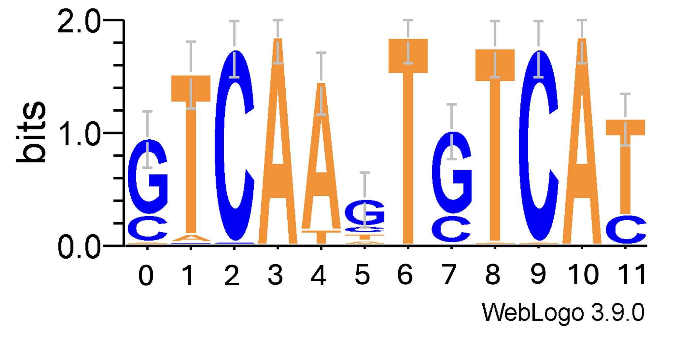

 | Index 3 | Index 9 | Joint Distribution (Average)
A | 1 | 0 | 0.5
C | 0 | 1 | 0.5
T | 0 | 0 | 0
G | 0 | 0 | 0
Information Content: | 2.0 | 2.0 | 1.0
Table 2. Concatenated PPM of the simple example, where only indices 3 and 9 are shown for illustrative purposes. The full PPM would be 12 columns long, matching the sequence logo’s length of 12 base pairs.

In this case, the PIC compared to a uniform null was computed to be 1.0, meaning that 1 bit of information was conserved between these two indices (compared to a maximum possible of 2). However, the consensus of these two indices (i.e., the most probable nucleotides at positions 3 and 9, which are A and C respectively) implies that they have neither a direct repeat relationship (which should be A-A or C-C), nor a palindromic one (A and T).

This means that a relatively high information content does not necessarily denote a true direct or inverse relationship. To ameliorate this, we applied a similarity penalty to the PIC to denote that this is not a useful observation for the direct or inverse pattern search. As seen in Table 3 below, the Pearson correlation was eliminated as a standalone metric as it fails for situations where both members of comparison are uniform (hence returning a perfect 1.0 correlation), nor was the KL appropriate due to its asymmetry resulting in two drastically different measures of divergence.

Using the JSD as a standalone metric has the same disadvantages as the Pearson for similar reasons, but it is bounded from 0 to 1, which is advantageous as a penalty metric for the nonzero 0 to 2 range of the PIC. Using the Pearson as either an additive or subtractive penalty for the PIC would require special handling of the signs.

Index Pairs | Scenario | KL | Pearson | JSD | PIC | PIC – JSD | PIC * Pearson
 | Low IC + strongly correlated (uniform) | 0 | 1 | 0 | 0 | 0 | 0
3, 10 | Full IC + strongly correlated | 0 | 1 | 0 | 2 | 2 | 2
3, 9 | Half IC + neg corr | 32 , 6 | -0.333 | 0.5 | 1 | 0.5 | -0.333
0,7 | Half IC + full correlation | 0 | 1 | 0 | 1 | 1 | 1
Table 3. Scenario modeling the pitfalls of various concordance metrics using the simple example. We see the effect of applying the JSD as a penalty, and the downsides of using the Pearson and JSD alone in uniform cases.

After defining and selecting the key similarity measure, we can compute all the pairwise metrics for each unique combination of the indices within the PWM. This results in a new matrix of the selected metric:

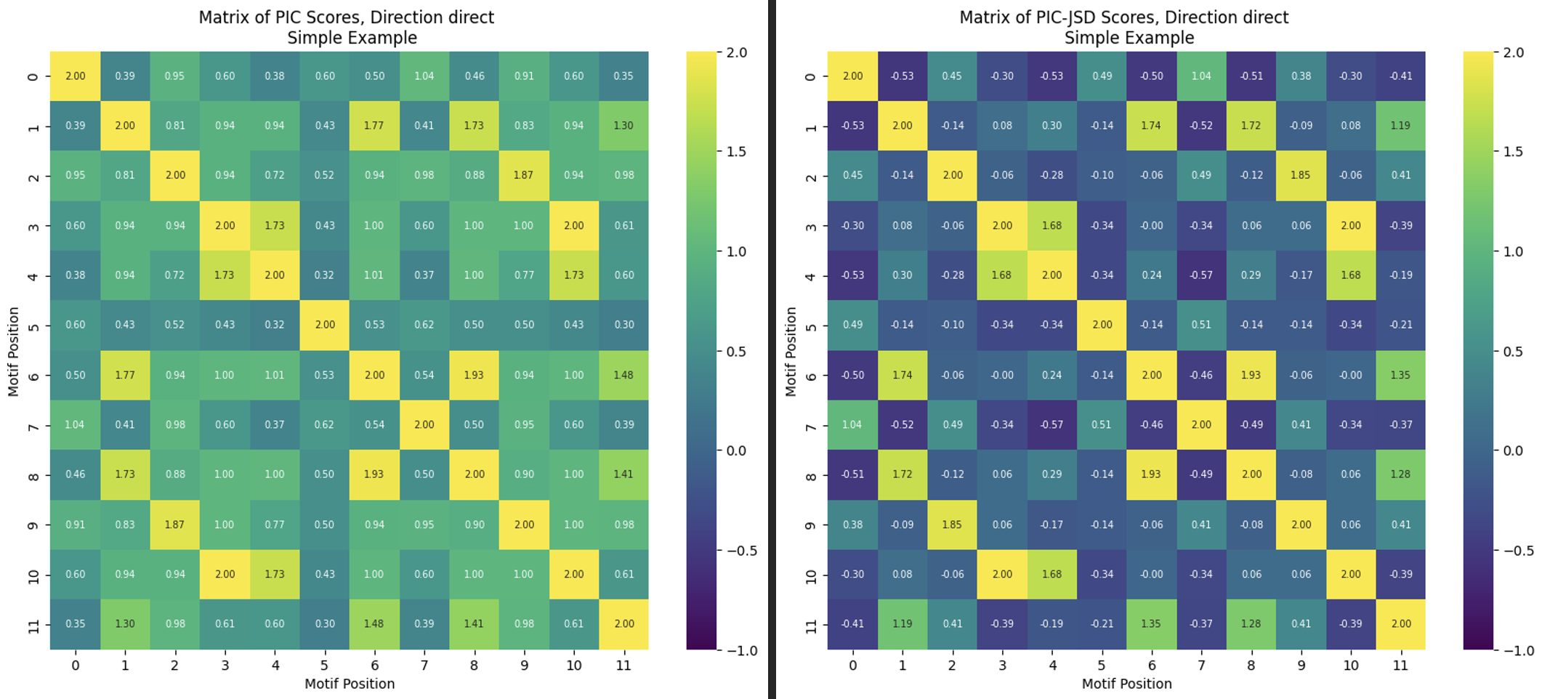
Figure 4. A comparison of the matrix of PIC metric vs that of the PIC – JSD.

We see in the matrices above the impact of the JSD penalty on the PIC, which is minimal though notable at observations such as row 11 column 4, where the penalty results in a negative metric. The JSD penalty acts as a filter that can refine the result depending on what threshold we set to detect contiguous chains of high-value pairwise relationships, e.g., nonzero values of the metric only.

Detecting and Scoring Candidates in Diagonal Form

After visualizing the matrix of the selected metrics, we see that candidate patterns are reflected in unbroken diagonal runs of “high” metrics. In the simple example above, we can see that the candidates (7,0); (8, 1); (9, 2); and (10,3) form an unbroken diagonal run, which corresponds to the nucleotides GTCA-GTCA from the sequence logo. Mapped back to the sequence logo, the matrices above visualize this direct repeat relationship:

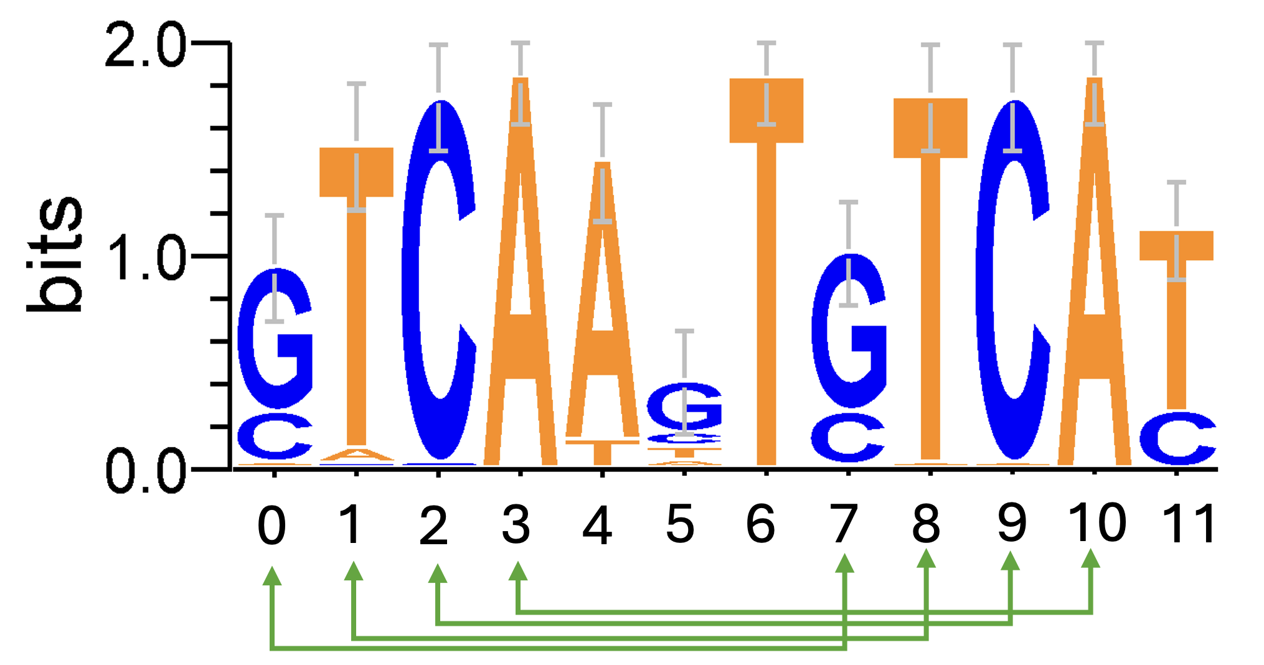
Figure 5. A sequence logo visualization of the direct repeat pattern suggested by our plotted IC – JSD metric.

However, the definition of what constitutes a “high” metric value for inclusion in the diagonal run search is arbitrary. Although the simple example above might appear obvious, the sequence logo shows some ambiguity in the G-C probability at the 0th and 7th positions. Indeed, if we set the threshold for inclusion as any value greater than 1.7, the detected putative motif would have been TCA-TCA instead, because the PIC-JSD value at cell (7,0) would be too weak of a signal for inclusion in the diagonal. Thus, we must determine the cutoff for what constitutes a high metric, which will in turn determine the starting and beginning of the putative candidate.

The simplest solution, which is similar in concept to algorithms like MEME, is to prompt the user to set a parameter for the desired length of discovered direct or inverted patterns. The DRIPPY pipeline allows for this. Alternatively, a more dynamic solution is offered in the form of an option to set a fixed or adaptive percentile-based threshold cutoff.

Rather than requiring the user to essentially guess how long they expect the detected repeat pattern to be, the DRIPPY pipeline can set a range of thresholds based on the PIC of the PWM and adaptively iterate through them. In practice, however, users may opt to view the distribution of the PIC-JSD metric to choose their own threshold.

Below, we reproduce the histogram of the PIC-JSD metrics.

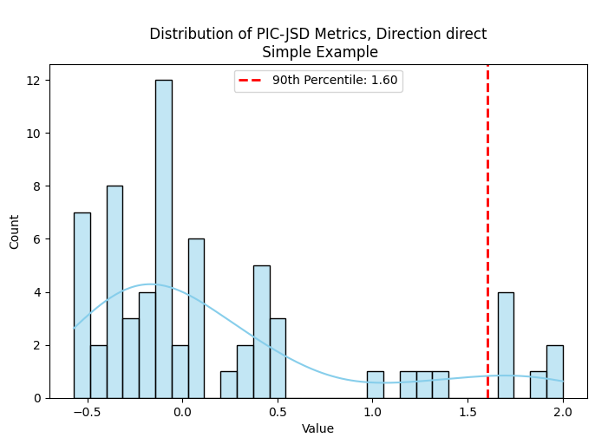
Figure 6. Histogram distribution of the PIC-JSD metrics (lower left triangle of the matrix only, as it is mirrored across the main axis).

Here, a fixed 90th percentile was used to determine the cutoff for inclusion in the search for diagonal runs. This means that users set the search threshold based on the statistical distribution rather than setting an arbitrary candidate length. Notably, for the cutoff, we use the PIC, and not the hybrid PIC-JSD metric, because the purpose of the cutoff is to first ascertain the candidate pool and answer the question of whether an index pair has enough information signal to matter, after which the diagonal search operates by evaluating the hybrid JSD-penalized metric.

Users can also set an acceptable range of percentile cutoffs. In this option, the algorithm decrements the percentile when necessary until it finds candidates of the default minimum length of two base pairs (or whichever minimum length was set by the user). In this way, the thresholding process can act more adaptively.

After a threshold is set, the search acts in a greedy manner, traversing the lower left triangle of the metrics matrix as it is mirrored on the identity axis. Once it encounters a value that meets or exceeds the threshold, it proceeds to the next diagonal value in the matrix to grow a diagonal candidate, ceasing if the next value fails the threshold.

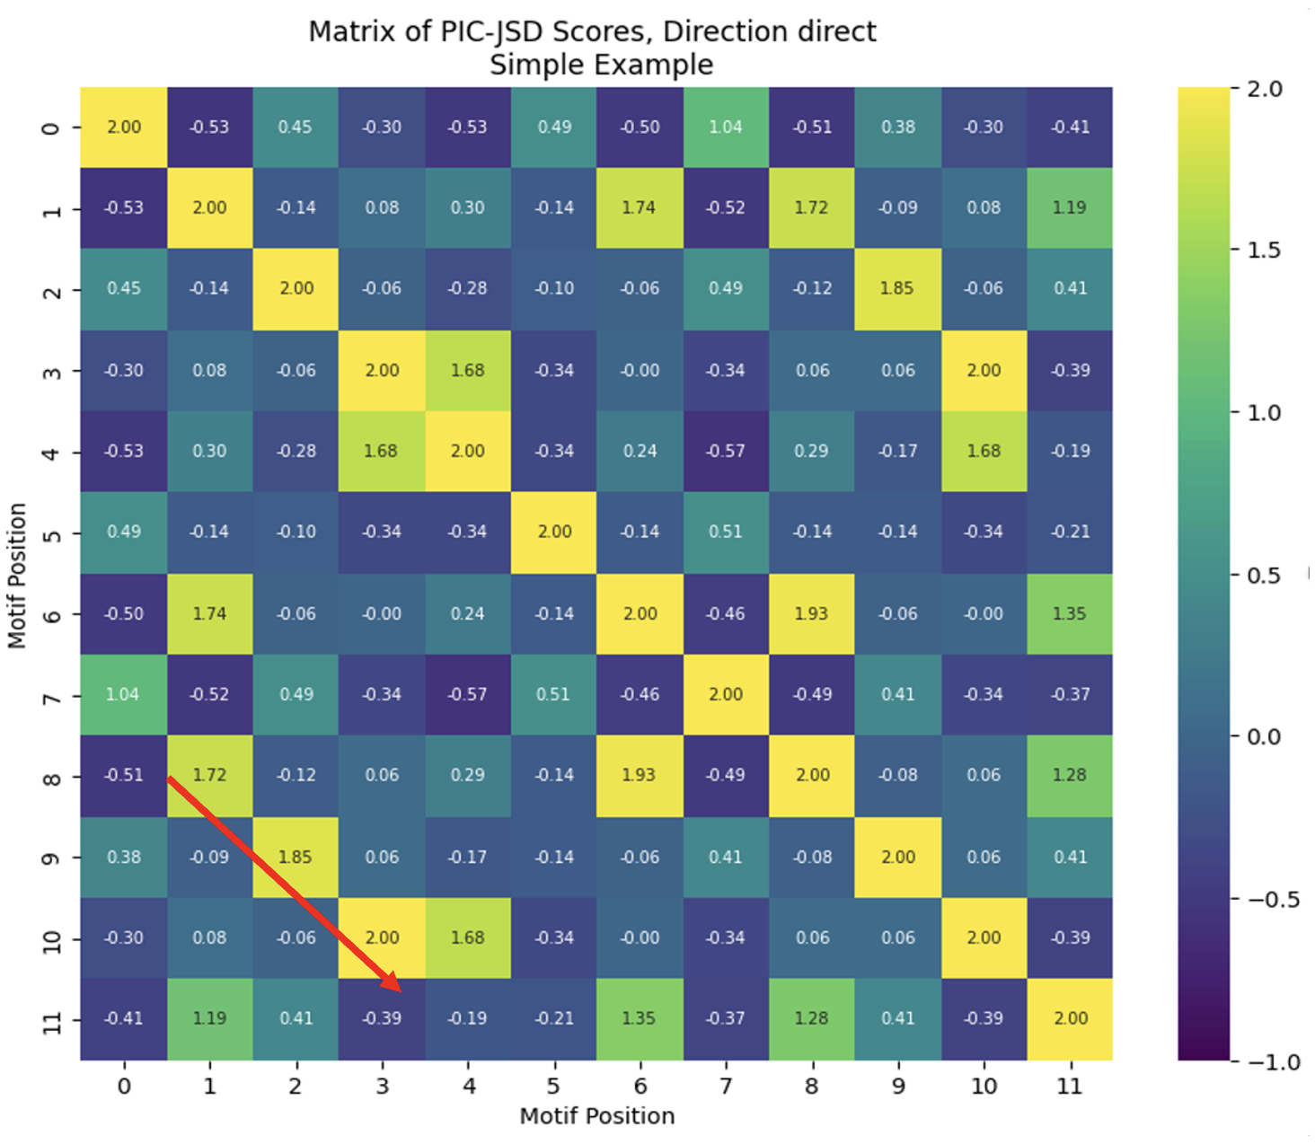
Figure 7. The PIC-JSD matrix with arrows denoting the direction of traversal in the search.

This search method results in multiple candidates, each with their own score, which is simply the sum of the metrics of their constituents. In our simple example, the only detected candidate would have a score of 1.72 + 1.85 + 2.00 = 5.57.

Significance Testing with Bootstrap Distributions

Once the diagonal candidates are gathered, DRIPPY evaluates the found candidates with bootstrapping. The metrics are shuffled index-wise, such that a random shuffling of indices 0-9 is applied to both axes on the PIC-JSD matrix to destroy existing positional relationships in the PWM. For each iteration of the bootstrap, the same threshold and diagonal detection process is applied, and the highest score of the best candidate found in that bootstrap iteration is computed. These bootstrap candidates’ scores form the bootstrap distribution.

The logic behind this process is to construct a space in which any positional relationships within the PWM are effectively randomized. This sets a baseline for whether our results offer signal beyond random background noise. The original empirical scores are then compared to the bootstrap distribution to compute p-values that denote significance of the results.

Below, we see the results of the bootstrap process on the simple example. Intuitively, we expect that many of the shuffled matrices would have no diagonal runs greater than or equal to the default minimum length 2, leading to a bias towards zero-scores as no runs were found in most bootstrap iterations. We see a significant p-value for our empirically derived diagonal which scored 5.57 on the PIC-JSD metric.

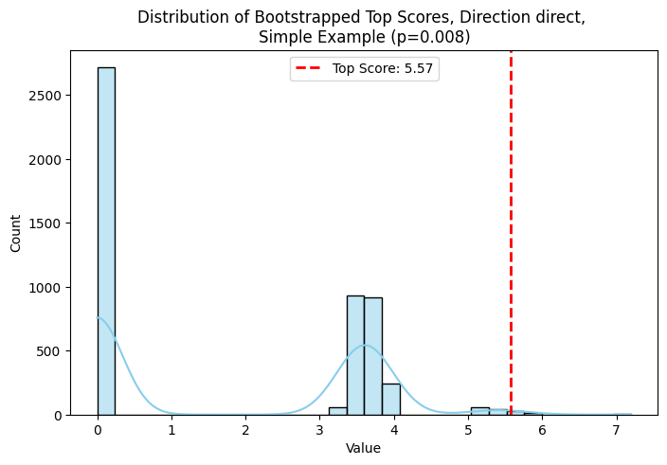
Figure 8. Bootstrap distribution of the PIC-JSD shuffled space.

Interpreting the results of the bootstrap analysis, we see that the detected candidate is better than random background noise, which indicates its strong candidacy as a direct repeat. The same analysis can be done to detect inverted repeats on the same PWM, where we see no significant signal at all in the outputs below:

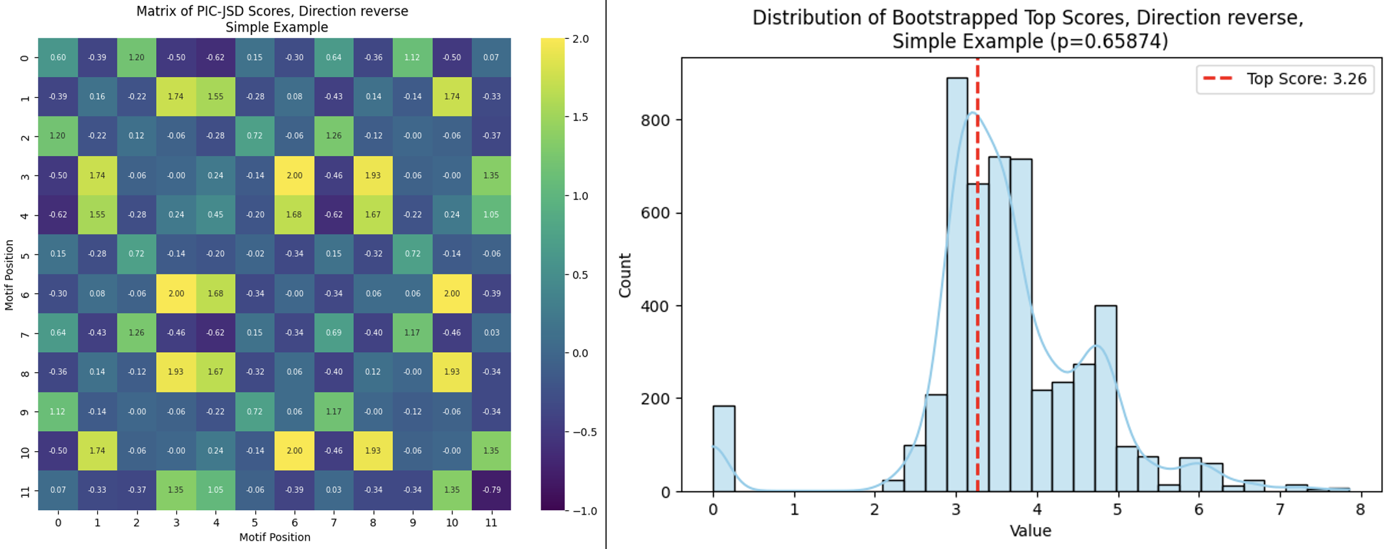
Figure 9. An inverse or palindromic search executed on the same simple example.

Note that in contrast to the direct repeat matrix, the inverted repeat diagonals run from bottom-left to top-right, which is a natural consequence of the inverted patterns being read in an outside-in orientation, though the axis of symmetry remains the same. Here, we only see a potential inverted repeat at (7, 2) and (6, 3), which is CA-TG. While by definition CA-TG is a palindrome, it is not particularly significant, as we see in the above bootstrap distribution.

Methods of Evaluating Results

The DRIPPY analysis was run on both the CollecTF and MEME data sets, which were labeled beforehand for whether we expect them to be direct repeat (DR) or inverted repeat (IR) patterns. In the case of the MEME data, there were some candidates that were labeled as neither a DR nor IR. We then ran the analysis to check for both DR and IR pattern types for each observation at multiple fixed percentile thresholds from 0 to 90 percent, with a minimum motif search length of 2 positions. We evaluated the results compared to the labels, as well as examining the behavior of the outputs when manipulating the user-defined parameters.

Thresholding Parameter Tuning and Result Concordance

Prior to discussing performance of results, understanding the behavior of the thresholding parameters is necessary to select the optimal tuning. After running the DRIPPY pipeline through threshold percentiles 0-90% in increments of 10, we compare the results to determine an optimal percentile threshold and discuss the impact to results. During the analysis, we found that p-value and agreement with the labels was not a complete representation of result quality. As the DRIPPY algorithm is greedy, a statistically significant result can sometimes result in inaccurate or misleading outputs, e.g. the pipeline might identify a highly significant DR as GTCC-GTCA, with a mismatch at the last position due to ambiguity in the PWM (i.e., at the fourth position, A and C might be equally probable). We measure and discuss this level of mismatch in terms of “concordance,” where in our GTCC-GTCA example, concordance is 75% due to the single mismatch of the four possible nucleotides in each comprising member of the direct repeat candidate. Concordance is discussed as another aspect salient to threshold tuning.

Classification Evaluation

After discussing optimal thresholding, we examine the classification performance more concretely with ROC and precision-recall curves. For the CollecTF data set, we have complete label coverage for whether the observations should be DR or IR. DRIPPY was run on the full data set, which results in multiple DR and IR candidates per combination of species and UniProtID. The outputted results at each percentile threshold will return all discovered DR/IR motif candidates, whether they are significant or not under the bootstrap distribution. This data was then aggregated so that the best candidates for the direct and inverted searches were found (i.e. the candidates with the lowest p-value for DR and IR search results), resulting in two p-values for each observation, unless no candidates of at least length 2 were found at all.

We then computed two sets of both the ROC and PR curves with the scoring metric being an inverted p-value (1 – p-value), calling these sets “component” and “system” curves.

The first component set of ROC and PR curves was plotted with the aggregated data to separately evaluate the performance of the direct and inverse search processes. Since the DR and IR search can be considered two entirely independent runs of the search algorithm, the ROC and PR curves plot the performance of both separately. This allows us to compare whether the DRIPPY pipeline was more sensitive to DR or IR patterns when considering the search as two separate components.

Secondly, for the “system” curves, we applied a simple winner-takes-all heuristic to combine both DR and IR search results, evaluating them holistically as a system. For each pair of direct and inverse search results for the same observation, whichever result had the lowest p-value was considered the best conclusion from the DRIPPY process, while the other was set to zero. This reflects the classification results as a One-vs-Rest (OvR) space, since the pipeline must distinguish between DR, IR, or insignificant/null classes. We then plotted another set of ROC and PR curves for this result to evaluate the full classification pipeline, wherein the DR and IR searches are evaluated in conjunction after a significance-based judgment call is applied.

We also evaluated confusion matrices based on the classical p <= 0.05 significance cutoff to produce inference from the DRIPPY pipeline. We perform a similar analysis with the MEME data, though the MEME data is slightly more challenging for classification as it also contains null values, i.e., some of the candidate motifs were explicitly labeled as neither a direct nor inverse repeat.

Results and Discussion

Prior to discussing precision, recall, and general performance of the DRIPPY pipeline, we first examine the impacts of manipulating threshold percentile, one of the user-adjustable parameters. As discussed in the Methodology section, the threshold percentile determines how many positions the DRIPPY will include in the final candidate motif output, as it determines what value of the PIC-JSD metric is considered high enough to constitute information-bearing signal. Lower thresholds imply more lenient inclusion criteria, and therefore longer output motifs.

However, the threshold percentile impacts more than just the search result size. It also impacts result quality and computing overhead. In the previous section, we defined a concordance metric that measures whether an alleged DR or IR pattern is truly a perfect DR or IR based on the outputted nucleotide sequence, which is measured by how many positions in the candidate are correct to the anticipated pattern.

Across the thresholds, we see below that as we might expect, lower thresholds tend to lead to more variability in results with poorer concordance. However, a low concordance measure does not necessarily imply an incorrect or invalid result: lower concordance is better explained as a simple consequence of a noisy PWM where at specific positions in the motif candidate, there is ambiguity in the consensus nucleotide.

It is also evident in the figure below that for high-throughput applications, users may be interested in constraining computation time, which also helps guide the threshold selection. Intuitively, computation time shows an inverse relationship with the threshold percentile as lower thresholds force the pipeline to search and evaluate longer candidates, hence returning more results.

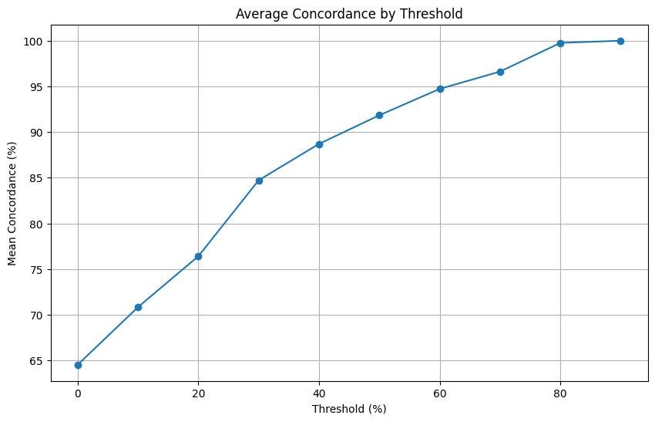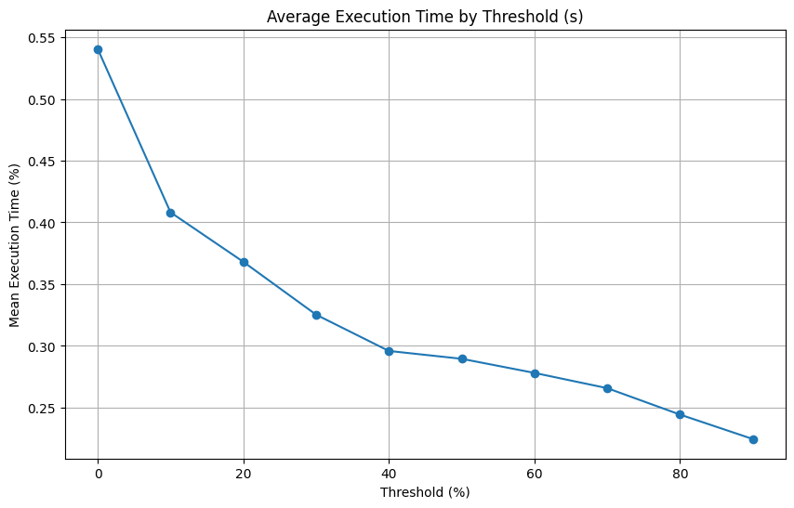
Figure 10. Concordance over thresholds and execution time by threshold for CollecTF data. Results are similar for MEME data.

Neither of these insights are particularly surprising, but they do assist with threshold tuning depending on user goals. A stricter, higher threshold percentage will result in motifs that are internally conformant to either the DR or IR pattern across all positions, and whether this result is a priority is dependent on the user’s intentions.

Tuning Threshold Percentage to Optimize Performance

Classification performance as a function of the threshold percentile setting is of paramount interest. We evaluate DRIPPY’s best conclusions with the p <= 0.05 threshold applied, meaning that inference was subject to statistical significance, even if the directionally best conclusion between the DR/IR search (i.e., the search result with the comparatively lower p-value) aligned with the label. P-values exceeding 0.05 were considered negative classifications.

We use Youden’s J-statistic, which is defined as J:

$$J = TPR - FPR$$

Where we define:
$$TPR = \frac{TP}{TP + FN} ; FPR = \frac{FP}{FP + TN}$$

We also use the F1 score, which is defined as:

$$F1 = \frac{2∙\left(Precision∙Recall\right)}{Precision + Recall}$$
Where:
$$Precision =\frac{TP}{TP + FP} \\ Recall = TPR$$

In the figure below, we see how the J and F1-statistics vary erratically across the thresholds in both the CollecTF and MEME data sets. These performance statistics were computed for the DRIPPY winner-takes-all pipeline which evaluated the best conclusion across the DR and IR search spaces, as this reflects the holistic analysis in practice.

The CollecTF data suggests that the optimal threshold percentile for the performance measures is 40%, though the MEME results are more mixed. At the same 40% threshold percentile, we maximize performance of the DR search, but the optimal value for IR searches is 70% for MEME data. However, it appears that the F1 score at 40% and 70% are somewhat comparable for the DR search. Therefore, depending on the goals of the user—i.e., do they wish to search solely for either DR or IR patterns, or both – the user could tune this parameter to their intention.

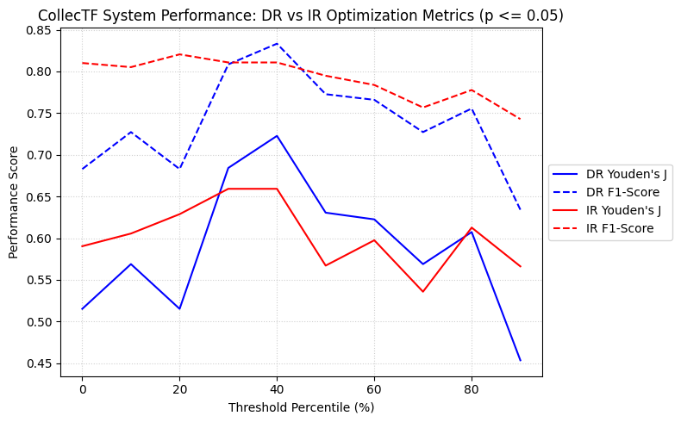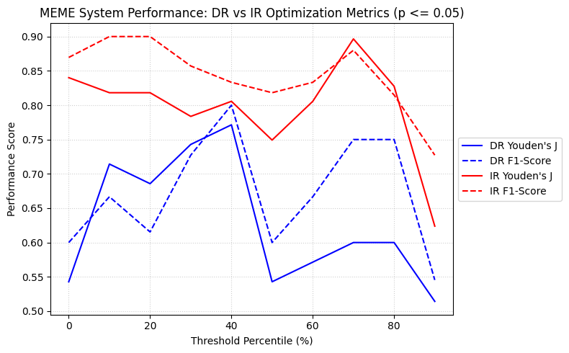
Figure 11. Youden’s J and F1-score across 0-90% thresholds for winner-takes-all results.

For the sake of report brevity, in the proceeding section we analyze performance (ROC and PR curves, confusion matrices) at the optimal 40% threshold for the CollecTF data, and at the 70% threshold for the MEME data.

Performance Evaluation

In this section, we discuss the classification performance of the DRIPPY pipeline. We find that applying the winner-takes-all heuristic results in better performance across both data sets, and an investigation of edge cases shows where the pipeline is vulnerable to ambiguities in PWMs.

ROC and PR Discussion for CollecTF Data

In the ROC curves below, which plot the true positive rate vs false positive rate, we see in the CollecTF data that across both the component and winner-takes-all system, DR patterns are slightly better classified.

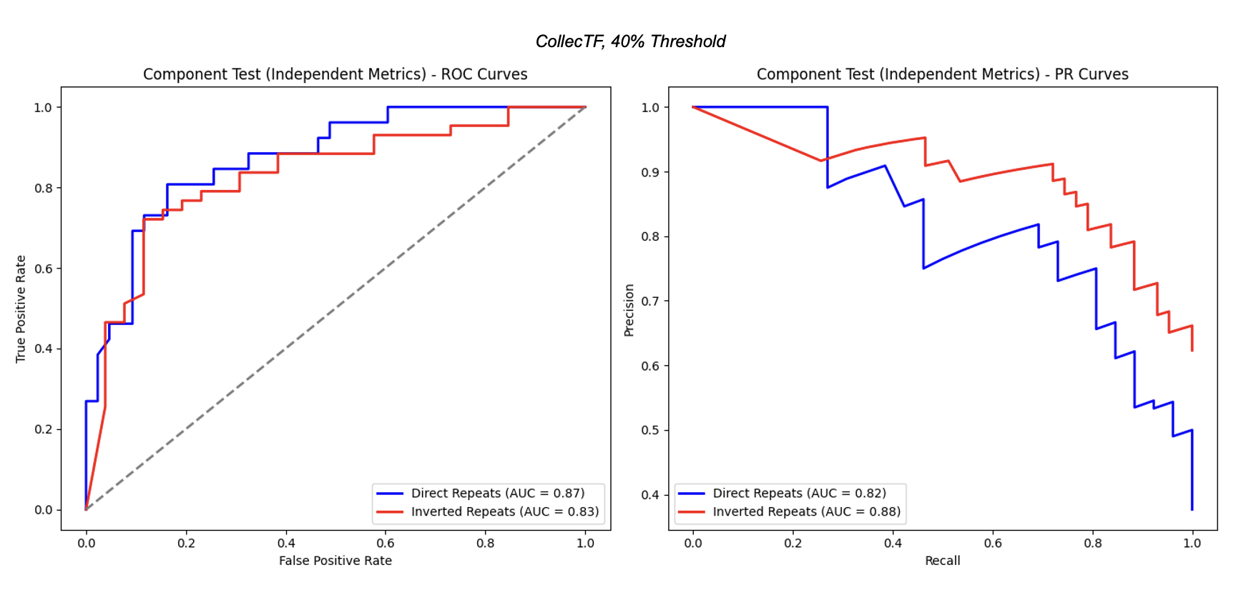
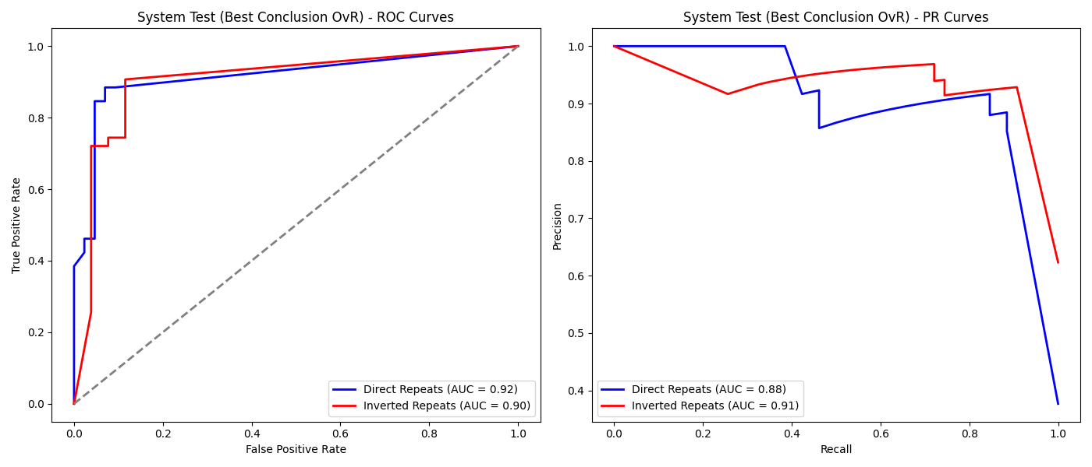
Figure 12. Component and system (winner-takes-all) ROC and PR curves for the DRIPPY classification of the CollecTF data set.

However, the differences are negligible, with an AUC of 0.92 and 0.90 respectively for DR and IR searches in the winner-takes-all system. Upon investigation in the system conclusions, we calculated that the DR observations had a higher proportion (80%) of statistically significant search results that were correctly aligned with the labels, whereas 71% of the IR group had significant agreement with the labels. This might indicate that while the cases were a minority, the DR data had more obvious patterns that were strongly significant compared to the RI group.

The PR curves show the precision (proportion of true positives out of all positive classifications) versus the recall (true positive out of the sum of TP and false negative classifications). Here, we see that for the CollecTF data, the IR patterns have a higher AUC across both the component and winner-takes-all spaces, though in the latter, the difference is negligible (0.88 vs 0.91).

Both the ROC and PR curves suggest that for the CollecTF data, the winner-takes-all heuristic results in a minor performance improvement in classification, a result of forcing the model to make a strict decision by penalizing statistically insignificant noisy results. However, unlike in the ROC curves, we see in the PR curves that the classification performance is marginally higher in IR patterns. This is likely because the PR curve is focused on positive classifications and ignores true negatives. The data was imbalanced in favor of IR patterns (43 inverse repeat patterns and 25 direct repeats). Therefore, it is not particularly surprising that the PR curves show better results for IR classification, because the IR patterns were in the majority class and therefore less challenging for the DRIPPY process to identify true positives.

ROC and PR Discussion for MEME Data

The ROC and PR curves for the MEME analysis show results aligned with the composition and smaller size of its data set. Recall that the data was highly imbalanced, with 5 direct repeats, 11 inverse repeats, and 24 none-type labeled patterns. Accordingly, the ROC curves show up to 15-point differences in favor of IR classification.

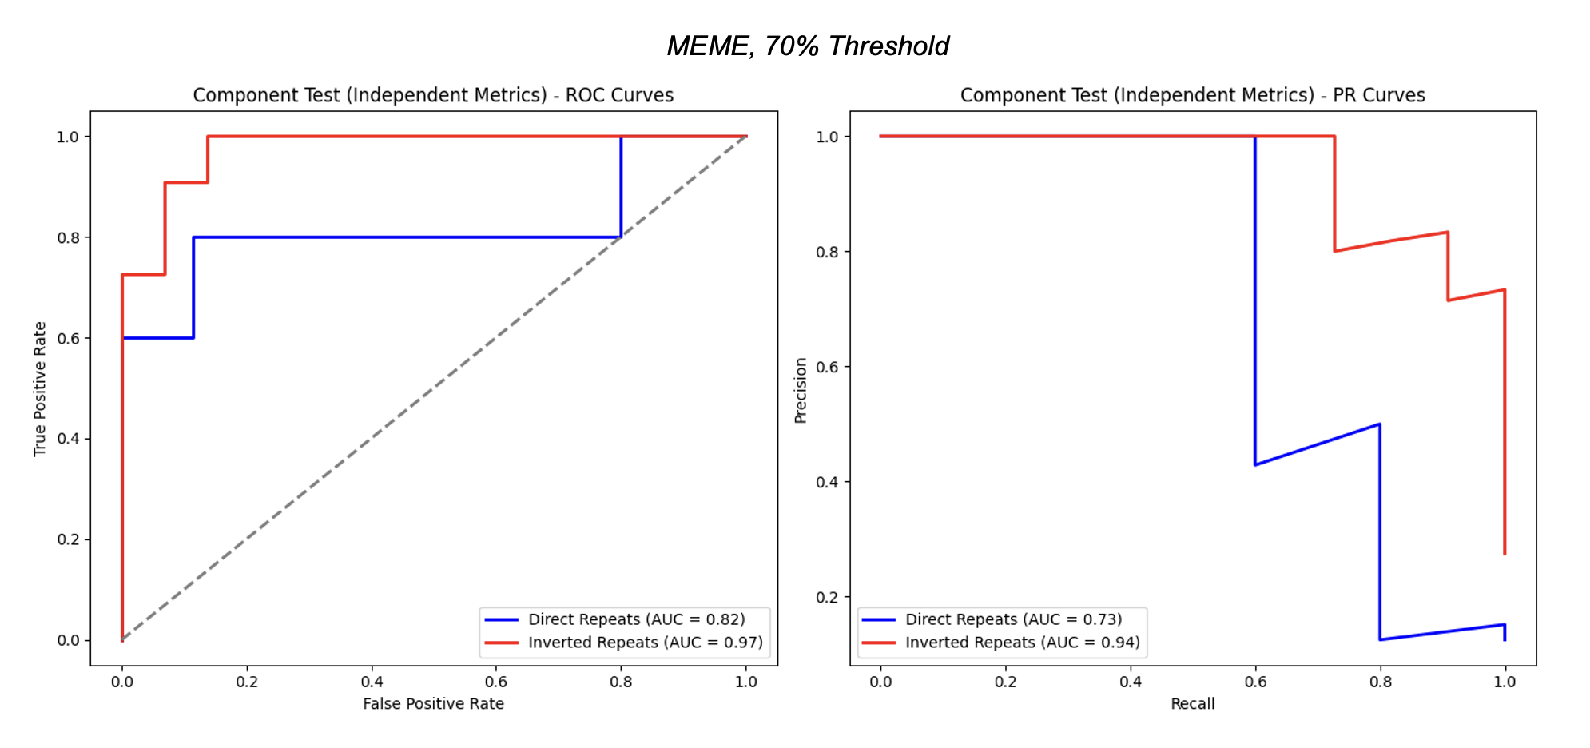
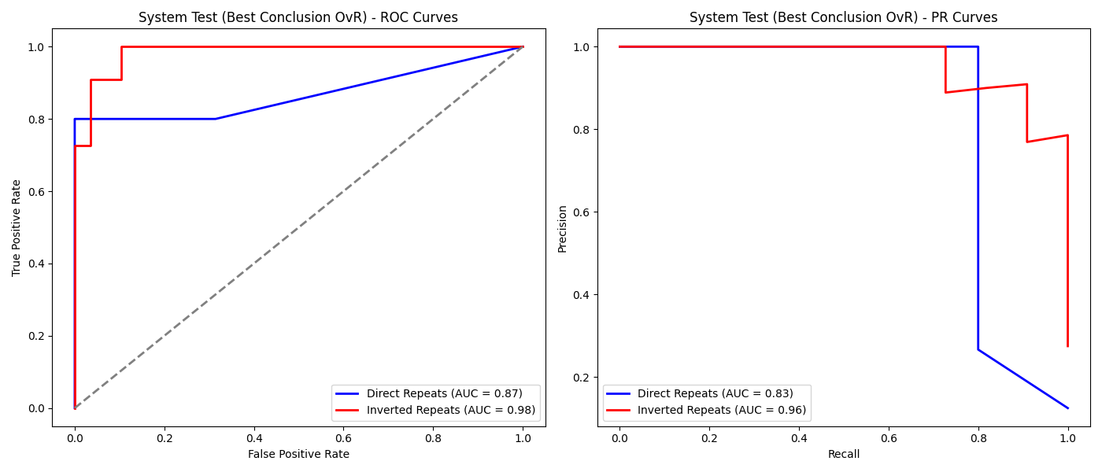
Figure 13. Component and system (winner-takes-all) ROC and PR curves for the DRIPPY classification of the MEME data set.

As we saw in the CollecTF data, the winner-takes-all system offers better performance than the individual DR and IR classification components, but the performance gap is much larger in the MEME set. This may be explained by the fact that the MEME set was noisier than the CollecTF set as it had a large group of null observations that were neither DR nor IR, meaning that the p-value significance acted as a crucial filter to exclude these noisy observations. In other words, the winner-takes-all heuristic was more useful here for more precise classifications.

Confusion Matrices and Edge Cases

Having established that the winner-takes-all heuristic offers better performance, we now review the confusion matrices across the CollecTF and MEME classification sets and examine edge cases that eluded correct classification. Rather than an exhaustive examination of all edge cases, we reproduce some high-level trends and representative cases for discussion.

We first compute and discuss the precision, recall, and accuracy, the latter defined with:

$$F1 = 2∙ \frac{Precision ∙ Recall}{Precision + Recall}$$

Inspecting the CollecTF Confusion Matrices

For the CollecTF data, the confusion matrices are reproduced below:

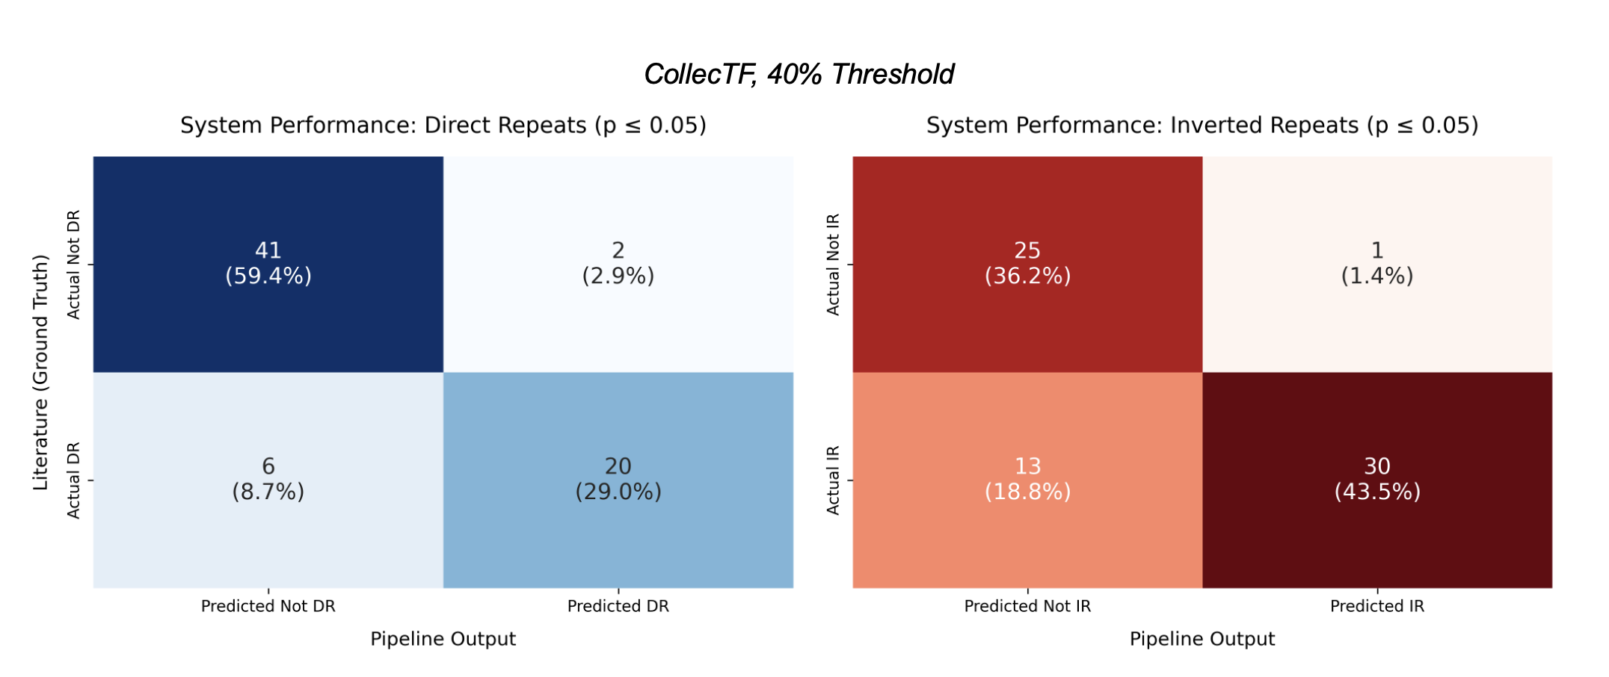
Figure 14. Confusion matrices for CollecTF data on DR and IR detection.

From these matrices, we calculate the following metrics:

CollecTF | DR | IR
Precision | 0.91 | 0.97
Recall | 0.77 | 0.70
F1-Score | 0.83 | 0.81

As we saw in our previous discussion, the IR classification achieved slightly higher precision than the DR, likely due to the class imbalance. However, the recall figures uncover where the pipeline failed to identify positive observations.

The six false negatives for the DR classification are characterized by a lower-than-average quantity of DNA sequences comprising their PWM. While the average sequence quantity for each unique species and transcription factor ID in the data set is 22 sequences, the six observations in the false negative group only had an average of 4 sequences. In other words, these observations have a particularly low number of samples that comprise their PWMs and putative motifs, meaning the margin for error to distinguish signal from noise is smaller. The most data-rich false negative, Yersinia pestis biovar Microtus str. 91001 with the TF Q7CFX0, had 14 sequences comprising the sequence logo below:

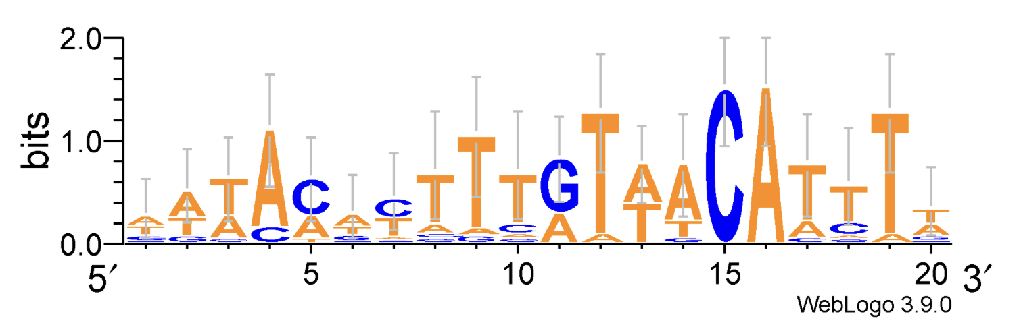
Figure 15. Sequence logo for false negative DR observation Yersinia pestis biovar Microtus str. 91001 with the TF Q7CFX0.

In this case, it appeared to be an incorrect labeling, as the CollecTF website labels it as an IR, though our literature-based label key identified it as a DR. The DRIPPY analysis labeled it as a weak IR as the p-value was not significant, though the best search result was an IR of pattern TGT-A-ACA. As we can see in the sequence logo above, the case for this pattern is not particularly visually obvious. Therefore, it is not surprising that the observation yielded a false negative, though interesting that the pipeline’s best conclusion was a weak IR in agreement with the CollecTF label.

Similar trends appear in the two DR false positives, where they were data-scarce with only an average of 3.5 sequences. An illustrative example of the two is Nostoc sp. PCC 7120’s transcription factor Q8YMM5, which was labeled as an IR, but both the DR and IR candidates were highly significant. This is explained by the fact that some patterns can be both DR and IR simultaneously as seen in the sequence logo and the model outputs:

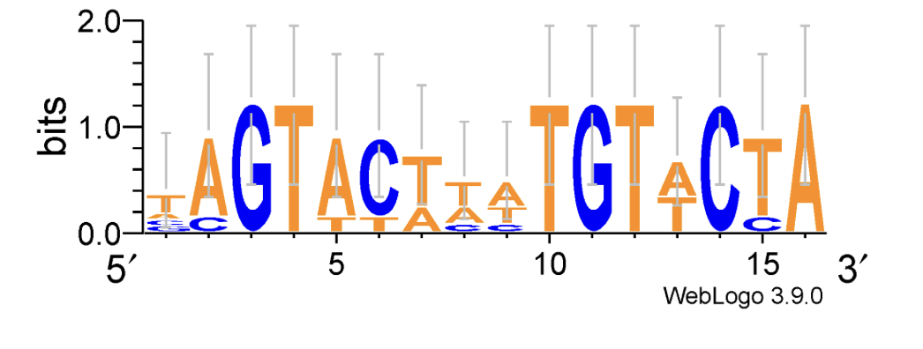

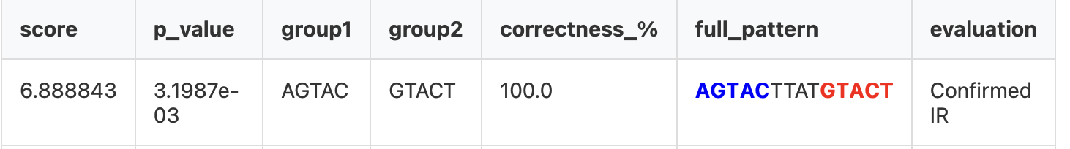
Figure 16. DRIPPY output for both the DR and IR search results of Nostoc sp. PCC 7120’s transcription factor Q8YMM5.

We see above that this example is arguably both a DR and IR when shifting the motif’s start by one position. Regardless, the pipeline output flagged both results as highly significant, with only a 0.001 magnitude of difference between the two p-values. While this yielded a misclassification relative to the labelling, results demonstrate that the model is still robust in finding actual candidates.

In contrast to the DR search, the IR results yielded more false negatives. The IR false negatives were data-poor, with an average of 2.7 sequences comprising each of their PWMs. Because of this dearth of sequences, the signal strength is harder to ascertain as we cannot draw any conclusions about which positions have more conserved information across a range of samples. A key example of this is Vibrio vulnificus MO6-24/O with the TF Q7M7I9, where we see only one sequence comprising it, resulting in a uniform sequence logo:

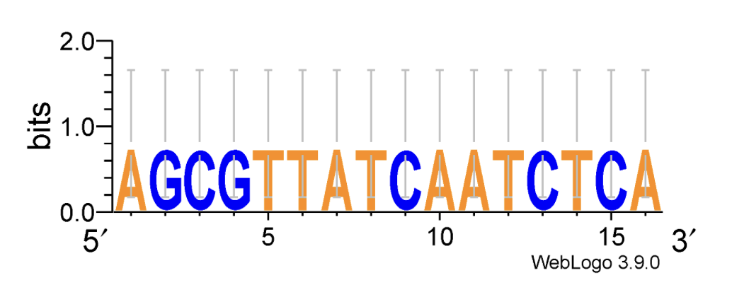
Figure 17. Sequence logo for Vibrio vulnificus MO6-24/O with the TF Q7M7I9, demonstrating a single-sequence PWM offers uniform signal and thus no information to ascertain a pattern.

Both p-values for the DR and IR search in this observation were insignificant (0.59 and 0.99). This false-negative conclusion reflects the data-scarce nature of this observation, as motif candidates that lack adequate information to support a strongly significant response are not overzealously classified as positive signals.

Inspecting the MEME Confusion Matrices

The MEME data set can be considered a challenging test set for the DRIPPY space due to the presence of explicit null values, and a more extreme class imbalance compared to the CollecTF data.

Below, we reproduce the same matrices and metrics as we did in the CollecTF results:

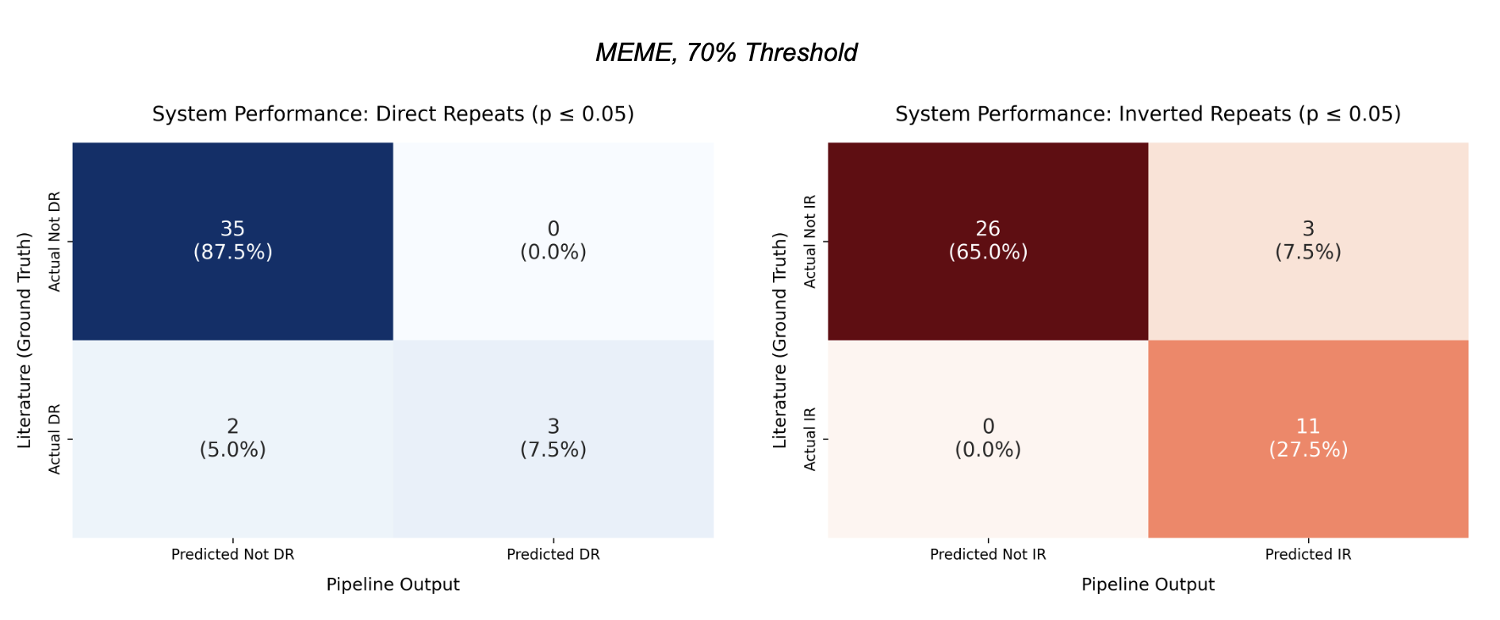
Figure 18. Confusion matrices for DR and IR detection for MEME data.

MEME | DR | IR
Precision | 1.00 | 0.79
Recall | 0.60 | 1.00
F1-Score | 0.75 | 0.88

In the DR search, there were two false negatives, one of which had a p-value of 0.053 that aligned with the DR label. This would be a borderline observation that, if the p-value threshold had been more optimized, would have been correctly classified.

The other false negative was distinctly challenging due to the presence of multiple poly-N patterns, where the same nucleotide is repeated in succession. In this case, there are many different potential direct repeat candidates, but deciphering which DR is significant is an ambiguous question.

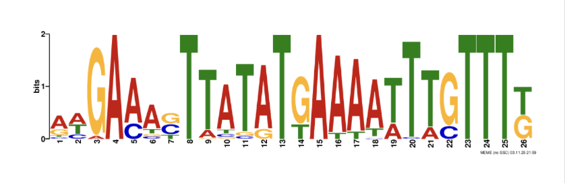
Figure 19. Sequence logo for MEME output 1, motif 5, with many poly-N patterns.

Unlike the CollecTF data, each observation in the MEME set had an average of 83 sequences comprising its PWM, meaning that the observations are data rich. Therefore, misclassifications are not attributable to a lack of data. This is a clear example of an edge case that is not easily tractable with the PIC-JSD metric, as the overrepresented poly-N patterns confound both the DR and IR search.

The MEME IR search yielded three false positives, all significant. All three observations were originally labeled as having no pattern at all by the human reviewer.

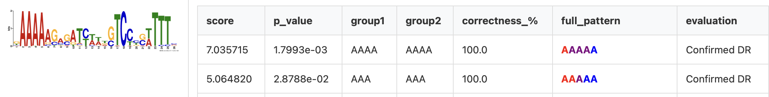
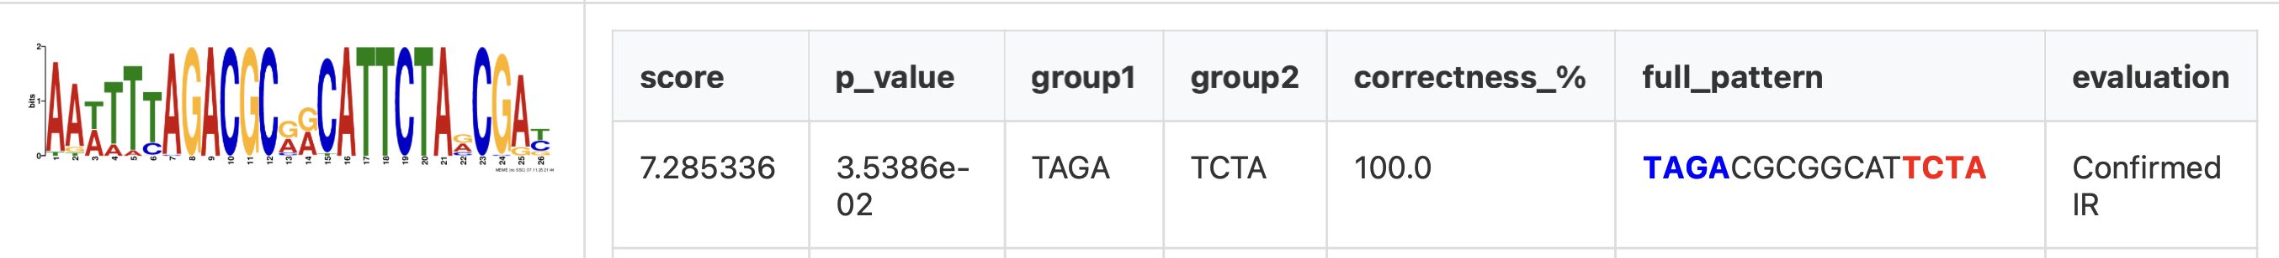
Figure 20. In order of appearance: MEME 3 Candidate 10, MEME 4 Candidate 3, and MEME 4 Candidate 4.

Like the DR edge case, two of them were rich in poly-N patterns, which confounded the pipeline. However, the third false positive observation might be considered a case where the DRIPPY pipeline identified a potential motif that eluded human review. Whereas the visual pattern is not obvious at first glance, the IR output is significant.

Overall, we see that across both the CollecTF and MEME data sets, the DRIPPY pipeline performs well in identifying both DR and IR patterns, though stumbling points include data-scarce observations with only a few aligned sequences comprising their PWM, as well as confounding due to poly-N patterns. While not perfect, the winner-takes-all heuristic pipeline appears to achieve reliable results that can help weed out noise among discovered candidates.

Conclusions

In the pantheon of algorithms developed and deployed to perform de novo motif discovery, an information-based statistical framework based on comparative genomics is an effective way to evaluate the quality of potential motif candidates and curate them further.

As demonstrated across both the CollecTF and MEME data sets, the DRIPPY pipeline leverages the known pattern of direct and palindromic sequences in bacterial TF motifs to establish a novel pipeline that detects such patterns in putative motif candidates, evaluating their statistical plausibility relative to a random background distribution. In this way, we exploit and apply the bacterial domain knowledge to filter for more likely TF binding sites, refining the candidate space found by algorithms like MEME.

An assiduous reader or future researcher may inquire why more sophisticated machine learning methods are not employed in this context. A key limitation of these methods is data scarcity and overfitting, as such models would require a significantly larger annotated data set to be successful and generalizable. Moreover, while a machine learning model could be easily trained to perform the DR/IR classification task, training such a model to return the boundaries and morphology of the putative motif as done by DRIPPY is another task entirely that would require an additional set of labeled data. The black box nature of such methods fails to provide an explainable, traceable, and semantic justification for the outputted results.

However, using the labeled data and outputs of our analysis, future researchers could train machine learning models to perform classification and candidate output tasks to verify the comparative performance and limitations of these architectures. Future investigations might also apply the DRIPPY pipeline to other bacterial TF types beyond the FNR-CRP, LexA, and OmpR families examined in this investigation, such as the Fur family. Inverted repeats are also found in eukaryotes, archaea, and viruses, which would offer more test spaces to apply this pipeline [44].

In conclusion, practical application of the DRIPPY pipeline allows researchers to refine their motif discovery algorithm results when investigating bacterial TFs, which in turn supports the optimal allocation and usage of wet lab resources on better-quality TF candidates with strong informational signal. By using these results to pare down the search space, we can reduce the size of the “needle in a haystack” problem in understanding active binding sites across the genome.

Bibliography

[1] “Transcription Factor - an overview | ScienceDirect Topics.” Accessed: Jun. 02, 2026. [Online]. Available: https://www.sciencedirect.com/topics/veterinary-science-and-veterinary-medicine/transcription-factor
[2] A. M. Ille, H. Lamont, and M. B. Mathews, “The Central Dogma revisited: Insights from protein synthesis, CRISPR, and beyond,” Wiley Interdiscip. Rev. RNA, vol. 13, no. 5, p. e1718, Sep. 2022, doi: 10.1002/wrna.1718.
[3] “Figure 13.1: Transcription and translation process. The picture shows...,” ResearchGate. Accessed: Jun. 11, 2026. [Online]. Available: https://www.researchgate.net/figure/Transcription-and-translation-process-The-picture-shows-the-transcription-factors-TF_fig7_249656139
[4] D. Senbeta and M. Kebede, “Investigation of promoter regions, motifs, and CpG islands in the regulation of gene expression in Trametes hirsuta strain 072,” J. Genet. Eng. Biotechnol., vol. 19, p. 160, Oct. 2021, doi: 10.1186/s43141-021-00261-9.
[5] L. Hertzberg, O. Zuk, G. Getz, and E. Domany, “Finding motifs in promoter regions,” J. Comput. Biol. J. Comput. Mol. Cell Biol., vol. 12, no. 3, pp. 314–330, Apr. 2005, doi: 10.1089/cmb.2005.12.314.
[6] S. Mohanty, P. K. Pattnaik, A. A. Al-Absi, and D.-K. Kang, “A Review on Planted (l, d) Motif Discovery Algorithms for Medical Diagnose,” Sensors, vol. 22, no. 3, p. 1204, Jan. 2022, doi: 10.3390/s22031204.
[7] B. He and K. Tan, “Understanding transcriptional regulatory networks using computational models,” Curr. Opin. Genet. Dev., vol. 37, pp. 101–108, Apr. 2016, doi: 10.1016/j.gde.2016.02.002.
[8] C. A. Grove and A. J. M. Walhout, “Transcription factor functionality and transcription regulatory networks,” Mol. Biosyst., vol. 4, no. 4, pp. 309–314, Apr. 2008, doi: 10.1039/b715909a.
[9] V. Saint-André, “Computational biology approaches for mapping transcriptional regulatory networks,” Comput. Struct. Biotechnol. J., vol. 19, pp. 4884–4895, Jan. 2021, doi: 10.1016/j.csbj.2021.08.028.
[10] L. Parab, S. Pal, and R. Dhar, “Transcription factor binding process is the primary driver of noise in gene expression,” PLOS Genet., vol. 18, no. 12, p. e1010535, Dec. 2022, doi: 10.1371/journal.pgen.1010535.
[11] “17.3: Expectation maximization,” Biology LibreTexts. Accessed: Jun. 11, 2026. [Online]. Available: https://bio.libretexts.org/Bookshelves/Computational_Biology/Book%3A_Computational_Biology_-_Genomes_Networks_and_Evolution_(Kellis_et_al.)/17%3A_Regulatory_Motifs_Gibbs_Sampling_and_EM/17.03%3A_Expectation_maximization
[12] P. A. Evans, A. D. Smith, and H. T. Wareham, “On the complexity of finding common approximate substrings,” Theor. Comput. Sci., vol. 306, no. 1, pp. 407–430, Sep. 2003, doi: 10.1016/S0304-3975(03)00320-7.
[13] I. I. Muhammad, S. L. Kong, S. N. Akmar Abdullah, and U. Munusamy, “RNA-seq and ChIP-seq as Complementary Approaches for Comprehension of Plant Transcriptional Regulatory Mechanism,” Int. J. Mol. Sci., vol. 21, no. 1, p. 167, Dec. 2019, doi: 10.3390/ijms21010167.
[14] K. R. Kukurba and S. B. Montgomery, “RNA Sequencing and Analysis,” Cold Spring Harb. Protoc., vol. 2015, no. 11, pp. 951–969, Apr. 2015, doi: 10.1101/pdb.top084970.
[15] W. Ma, W. S. Noble, and T. L. Bailey, “Motif-based analysis of large nucleotide data sets using MEME-ChIP,” Nat. Protoc., vol. 9, no. 6, pp. 1428–1450, 2014, doi: 10.1038/nprot.2014.083.
[16] S. Pepke, B. Wold, and A. Mortazavi, “Computation for ChIP-seq and RNA-seq studies,” Nat. Methods, vol. 6, no. 11 Suppl, pp. S22-32, Nov. 2009, doi: 10.1038/nmeth.1371.
[17] Z. Zhang and M. Gerstein, “Of mice and men: phylogenetic footprinting aids the discovery of regulatory elements,” J. Biol., vol. 2, no. 2, p. 11, 2003, doi: 10.1186/1475-4924-2-11.
[18] L. L. Gatlin, “The information content of DNA,” J. Theor. Biol., vol. 10, no. 2, pp. 281–300, Feb. 1966, doi: 10.1016/0022-5193(66)90127-5.
[19] C. E. Shannon, “A Mathematical Theory of Communication,” Bell Syst. Tech. J., vol. 27, no. 3, pp. 379–423, 1948, doi: 10.1002/j.1538-7305.1948.tb01338.x.
[20] T. D. Schneider, G. D. Stormo, L. Gold, and A. Ehrenfeucht, “Information content of binding sites on nucleotide sequences,” J. Mol. Biol., vol. 188, no. 3, pp. 415–431, Apr. 1986, doi: 10.1016/0022-2836(86)90165-8.
[21] T. L. Bailey, “STREME: accurate and versatile sequence motif discovery,” Bioinformatics, vol. 37, no. 18, pp. 2834–2840, Sep. 2021, doi: 10.1093/bioinformatics/btab203.
[22] S. Gupta et al., “In Silico Approach for Predicting Toxicity of Peptides and Proteins,” PLOS ONE, vol. 8, no. 9, p. e73957, Sep. 2013, doi: 10.1371/journal.pone.0073957.
[23] P. A. Pevzner and S. H. Sze, “Combinatorial approaches to finding subtle signals in DNA sequences,” Proc. Int. Conf. Intell. Syst. Mol. Biol., vol. 8, pp. 269–278, 2000.
[24] M. Tompa, “An exact method for finding short motifs in sequences, with application to the ribosome binding site problem,” Proc. Int. Conf. Intell. Syst. Mol. Biol., pp. 262–271, 1999.
[25] G. Z. Hertz and G. D. Stormo, “Identifying DNA and protein patterns with statistically significant alignments of multiple sequences,” Bioinformatics, vol. 15, no. 7–8, pp. 563–577, 1999, doi: 10.1093/bioinformatics/15.7.563.
[26] P. D’haeseleer, “How does DNA sequence motif discovery work?,” Nat. Biotechnol., vol. 24, no. 8, pp. 959–961, Aug. 2006, doi: 10.1038/nbt0806-959.
[27] T. L. Bailey, N. Williams, C. Misleh, and W. W. Li, “MEME: discovering and analyzing DNA and protein sequence motifs,” Nucleic Acids Res., vol. 34, no. suppl_2, pp. W369–W373, Jul. 2006, doi: 10.1093/nar/gkl198.
[28] T. L. Bailey and C. Elkan, “Fitting a mixture model by expectation maximization to discover motifs in biopolymers,” Proc. Int. Conf. Intell. Syst. Mol. Biol., vol. 2, pp. 28–36, 1994.
[29] T. L. Bailey, N. Williams, C. Misleh, and W. W. Li, “MEME: discovering and analyzing DNA and protein sequence motifs,” Nucleic Acids Res., vol. 34, no. Web Server issue, pp. W369–W373, Jul. 2006, doi: 10.1093/nar/gkl198.
[30] S. Heinz et al., “Simple combinations of lineage-determining transcription factors prime cis-regulatory elements required for macrophage and B cell identities,” Mol. Cell, vol. 38, no. 4, pp. 576–589, May 2010, doi: 10.1016/j.molcel.2010.05.004.
[31] A. M. Azmi and A. Al-Ssulami, “Encoded Expansion: An Efficient Algorithm to Discover Identical String Motifs,” PLOS ONE, vol. 9, no. 5, p. e95148, May 2014, doi: 10.1371/journal.pone.0095148.
[32] F. F. M. Liu, J. J. P. Tsai, R. M. Chen, S. N. Chen, and S. H. Shih, “FMGA: finding motifs by genetic algorithm,” Proc. Fourth IEEE Symp. Bioinforma. Bioeng., pp. 459–466, 2004, doi: 10.1109/BIBE.2004.1317378.
[33] Z. Shen, W. Bao, and D.-S. Huang, “Recurrent Neural Network for Predicting Transcription Factor Binding Sites,” Sci. Rep., vol. 8, no. 1, p. 15270, Oct. 2018, doi: 10.1038/s41598-018-33321-1.
[34] J. Yang et al., “Prediction of regulatory motifs from human Chip-sequencing data using a deep learning framework,” Nucleic Acids Res., vol. 47, no. 15, pp. 7809–7824, Sep. 2019, doi: 10.1093/nar/gkz672.
[35] A. Al-Tohamy and A. Grove, “Targeting bacterial transcription factors for infection control: opportunities and challenges,” Transcription, vol. 16, no. 1, pp. 141–168, doi: 10.1080/21541264.2023.2293523.
[36] A. Borges Farias, G. Sganzerla Martinez, E. Galán-Vásquez, M. F. Nicolás, and E. Pérez-Rueda, “Predicting bacterial transcription factor binding sites through machine learning and structural characterization based on DNA duplex stability,” Brief. Bioinform., vol. 25, no. 6, p. bbae581, Sep. 2024, doi: 10.1093/bib/bbae581.
[37] M. R. Leuze, T. V. Karpinets, M. H. Syed, A. S. Beliaev, and E. C. Uberbacher, “Binding Motifs in Bacterial Gene Promoters Modulate Transcriptional Effects of Global Regulators CRP and ArcA,” Gene Regul. Syst. Biol., vol. 6, pp. 93–107, May 2012, doi: 10.4137/GRSB.S9357.
[38] A. Al-Tohamy and A. Grove, “Targeting bacterial transcription factors for infection control: opportunities and challenges,” Transcription, vol. 16, no. 1, pp. 141–168, Jan. 2025, doi: 10.1080/21541264.2023.2293523.
[39] S. Kılıç et al., “From data repositories to submission portals: rethinking the role of domain-specific databases in CollecTF,” Database, vol. 2016, p. baw055, Jan. 2016, doi: 10.1093/database/baw055.
[40] I. Erill, S. Campoy, S. Kılıç, and J. Barbé, “The Verrucomicrobia LexA-Binding Motif: Insights into the Evolutionary Dynamics of the SOS Response,” Front. Mol. Biosci., vol. 3, p. 33, Jul. 2016, doi: 10.3389/fmolb.2016.00033.
[41] T. D. Schneider and R. M. Stephens, “Sequence logos: a new way to display consensus sequences.,” Nucleic Acids Res., vol. 18, no. 20, pp. 6097–6100, Oct. 1990, doi: 10.1093/nar/18.20.6097.
[42] M. L. Menéndez, J. A. Pardo, L. Pardo, and M. C. Pardo, “The Jensen-Shannon divergence,” J. Frankl. Inst., vol. 334, no. 2, pp. 307–318, Mar. 1997, doi: 10.1016/S0016-0032(96)00063-4.
[43] D. Belov and R. Armstrong, “Distributions of the Kullback-Leibler divergence with applications,” Br. J. Math. Stat. Psychol., vol. 64, pp. 291–309, May 2011, doi: 10.1348/000711010X522227.
[44] R. P. Bowater, N. Bohálová, and V. Brázda, “Interaction of Proteins with Inverted Repeats and Cruciform Structures in Nucleic Acids,” Int. J. Mol. Sci., vol. 23, no. 11, p. 6171, Jan. 2022, doi: 10.3390/ijms23116171.

Supervisor (and Tutor) signatures

